*Project Senna*

Proposal

A program-controlled race car learns (using a genetic algorithm) how to find the fastest time round a track, and the user can choose to race any specific generation (skill level) of the AI to race against on each track.

I would find it interesting since I have a passion for cars and racing, I think it would be cool to be able to see how an AI goes about finding time around a track, and how it may act differently to a human trying to learn how to be the fastest. I’m not sure whether to do it in 3D or 2D yet but if I were to do it in 3D it would be a great way to learn the skills within 3D graphics.

It would require a decent knowledge behind the math’s and computation behind a self-learning algorithm, since I want to implement it from scratch (without any external libraries). The project would also need specific attention to speed since ideally there would be loads of cars (controllers) learning at the same time, so learning optimization strategies for the language I use will be key.

I do believe that it’s a feasible idea, since the complexity can range from simple to extremely complex, i.e. I can build up to the harder complexity stuff when the base project is working, without ruining the original concept.

After doing some brief research online, I found a number of other implementations of this AI experiment : for example **Code Bullet** on YouTube <https://www.youtube.com/watch?v=r428O_CMcpI&t=860s&ab_channel=CodeBullet> , and numerous examples on github.com. However, I have yet to see an implementation which boasts realistic, more complex controller physics along with the ability to chose to save and race a specific controller. It will be interesting to see how quickly a human’s skill can compare to an AI which has been training for a certain length of time.

*Possible machine learning algorithms*

1. Genetic algorithm with Neural Network – this is my number one pick, since it curiously reproduces the learning behaviour of a human which is particularly entertaining to watch. It also allows for an infinite amount of optimization and customization in the way the neural network is modified and improved which makes this a desirable method for development. Finally, this technique is relatively simple to implement as you avoid a large amount of the frankly painful maths attached to other machine learning algorithms.
2. Classic Reinforcement learning ( Q-learning ) – a very efficient and optimal algorithm for this project. It involves a predetermined environment, a set of actions and a set of rewards which are distributed to each controller to **reinforce** their behaviour if they are seeing success or to **discourage** suboptimal behaviour. However, this technique is particularly complex, requiring huge amounts of very complicated maths and optimization algorithms to work properly. Therefore, I will reject this approach due to its dubious feasibility at this stage of my computer science development.

**SO Genetic Algorithm approach is my algorithm of choice!**

*Stakeholders*

*Students*

I predict my stakeholders to be students or young adults with an interest in AI and environmental simulations, with particular interest in motorsport. My application will provide a fun and interactive experience with machine learning, which will hopefully inspire other young developers to experiment with the somewhat ominous field of computer science and to create their own simulations. Teachers and tutors could use my project to introduce basic self-learning techniques and the **RACE against** feature should keep students engaged and entertained while learning.

*Professionals*

Additionally, when the AI controllers eventually optimize their lap times, their strategies to traverse the track may unveil new or reinforce preexisting notions about motorsport. Therefore, depending on the results of the simulation – my simulation may be utilized by novice motorsport teams to demonstrate optimal racing lines to their racers.

*Requirements*

Importance Level:

* Critical
* Would be nice
* Polishing touch

|  |  |  |  |
| --- | --- | --- | --- |
| Feature | Description | Importance | WHY? |
| App must have a UI | Track and cars drawn onto the graphics window | Critical | App needs a graphics interface to illustrate the simulation in action |
| Main menu | Have choice to start a new simulation | Critical | App requires a interface so user can start a simulation |
| AI controllers | Have each car controlled by a neural network controller which takes in environment data and outputs an action | Critical | Pretty self-explanatory |
| Option to select a racer | Select a racer should display a window of stats and info about that controller | Would be nice | Not totally necessary but really useful for development and allows interactivity |
| Random track generation | Option to choose a new **random map,** should use algorithm to generate a new useable track. | Would be nice | Would be very useful and interesting to see how a controllers skill transfers between tracks |
| Save and load previous controllers | Provides an option for user to save a current controller (racer) or load an old controller | Polishing touch | Again, not essential but a lovely touch and saves time during my development |
| Cars should have movement physics | Allow interface for controller to move the car how they want, accelerate, brake, steer. | Critical | Very self-explanatory, cars need a way to move around the track |
| Timing and checkpoint system | Stopwatch system which times AI cars throughout sectors and gives these times back as feedback | Critical | This is the way AI controllers gain feedback and thus learn and improve |
| Neural network and genetic algorithm | Implementation of neural networks and genetic algorithm used to optimize the network’s weights and sizes. | Critical | How the AI **learns** this is perhaps the most critical feature, its required for the simulation to successfully run. Probably the most time-consuming step of development |
| Pause / Play feature | Feature which allows user to stop and start the simulation during runtime | Would be nice | Useful device for development and also for user’s wanting to inspect a controller’s data at a single point in time. |
| Leaderboard | Display section which shows a list of the fastest racer’s | Polishing touch | Can tell user which AI racer to watch and inspect. |

*Limitations*

|  |  |
| --- | --- |
| Limitations | Explanation |
| Runtime speed | For large population generations of controllers, depending on individual hardware performance. |
| The UI | The library I’m using for UI design is slightly limited so the UI may be a little limited but for a simulation this isn’t really a big deal. |
| Car Physics | The car physics in this game will, naturally, be quite inaccurate since modelling the actual physics of each moving component of the car would be a bit redundant and kill run speeds. |

*Hardware requirements?*

* Means of input and output: monitor and keyboard and mouse.
* Computer with enough hardware to run a moderately heavy application – should run smoothly on any computer produced after the 2000’s. There are no specific hardware or software requirements since the project will be packaged as a simple .exe file.

***Computational Methods***

*What makes this project suitable for a computer:*

1. The simulation is easily decomposable into a series of features which need to interface with each other to run
2. Large amounts of arithmetic operations need to be run in milliseconds, perfect for a computer. This includes the genetic algorithm manipulating the neural network’s parameters and vast linear algebra calculations required to ‘run’ through the neural network. These operations happen hundreds of times a second for every controller on the screen – therefore a computer is not only useful but **required** to run this experiment.
3. Visualization is an integral component to my project since the user’s must be able to watch along as the AI controllers learn and gradually improve over time, without a UI this would be impossible. With a computer drawing the environment and UI to the screen is a relatively trivial task. Additionally with the aid of IO devices the user will be able to interact with the simulation and ultimately remain engaged.

My Development Plan – 12 Small steps

**Stage One**:

Set up and configure the graphics library to run without errors and open a window with correct settings.

**Todo:**

* Initialise the graphics library
* Draw window to screen
* Allow user to close screen
* Draw at correct size
* Give window a name

Stakeholders should find the programs window easy to use and devoid of issues (i.e. we don’t want the program crashing when the user tries to resize it).

|  |  |  |  |  |  |
| --- | --- | --- | --- | --- | --- |
| Test No. | Description | Test Type | Test Data | Expected | Actual |
| 1a | Running the program after importing the graphics library | - | - | Should run without errors |  |
| 1b | Testing whether window opens and closes correctly | - | - | Window should open and then can closes when **X** button is pressed |  |
| 1c | Drawing window at specific size | - | Width = 800  Height = 600 | Window should create at correct dimensions (i.e. Should change from default size to the specified one). |  |
| 1d | Window displays correct window name | - | Name = “Racers” | The widow should display a title of “Racers” at the top |  |

**Stage Two**:

Create a car object and draw it to the screen. Implement movement and physics for the car: **steering angle, acceleration, speed, braking**. For development purposes allow movement to be controlled by keyboard

**Todo:**

* Implement and handle physical attributes to car
* Create a Car class
* Draw the car to the screen
* Implement user controls for the car
* Implement braking, and accelerating
* Implement steering and rotate car sprite accordingly

For the stakeholders, the car’s physics should be intuitive enough to observe and see what a car is **trying to do** however the physics doesn’t need to be implemented with life-like realism

|  |  |  |  |  |  |
| --- | --- | --- | --- | --- | --- |
| Test no. | Test Description | Test Data | Test Type | Expected Result | Actual Result |
| 2.a | Test keyboard input accelerate and friction | **W key input** | - | Press w key and the car will accelerate in the direction of the sprite |  |
| 2.b | Test steering | - | - | Press a key and the car steers left **only** when moving. And visa-versa for right key. |  |
| 2.c | Test braking | **S key input** | - | When the s key is pressed **and** the car is moving, the car’s velocity should close to a stop |  |
| 2.d. | Car sticking to screen | - | Boundary Test | When the car hits the border of the screen it should be blocked as if it has hit an invisible barrier |  |

**Stage Two**: **Stage Three:** Create a *track* object which handles track limits, drawing itself and checkpoints (which divide the track into sectors).

1. **Stage Four:** Implement the backend for neural networks, including **matrices, matrix operators,** and a ***network* object** which keeps track of **layers, weights** and allows easy abstraction from the inner complexities.
2. **Stage Five:** Attaching a controller to a **car** object so it can use its own neural network to move the car, this involves choosing what data inputs enter the network and deciding the ‘bare metal’ anatomy of the network.
3. **Stage Six:** Implementing the genetic algorithm for taking 2 controller’s and mixings their networks (plus a little mutation) to create a new controller.
4. **Stage Seven:** Adjust population object to keep track of various sector times, lap times and display them to the user. It should also track the best performing car at all times.
5. **Stage Eight: UI OVERHALL** – make UI pretty and implement the features such as the **controller inspector.** I would aim to make the track and cars easier on the eyes also.
6. **Stage Nine:** AI running and testing! Allow time to tweak the inputs, outputs and starting set up of AI **networks** to allow for quicker progress. Attempt to fix (or at least document) any strange behaviour of the **AI.** Create a smooth progression between generations and optimize the genetic algorithm functionality to produce more effective racing.
7. **Stage Ten** – Implement the **RACE** feature where users can race against selected AI across a lap (pausing progress of population for that time).
8. **Stage Eleven -** Polishing touches to **AI** and physics. Could implement **sound effects** and **particle effects** etc. Mostly testing **AI** to ensure users will be able to watch the generations progress every time they boot up the application. Also, any **ease-of-use** features to be implemented here.
9. **Stage Twelve** – RELAX!

Development Stage 1

*Development environment set up, library initialization and window setup.*

My programming language of choice **rust** because of its superior processing speeds and ergonomic syntax. For displaying graphics to the screen, I will be using a relatively high-level graphics library called **macroquad**.

Creating the rust working environment

1. Create a project using **cargo** tool

This is what the project tree looks like after being created

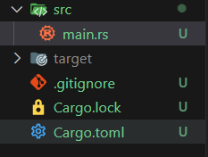

1. Add the **macroquad** library

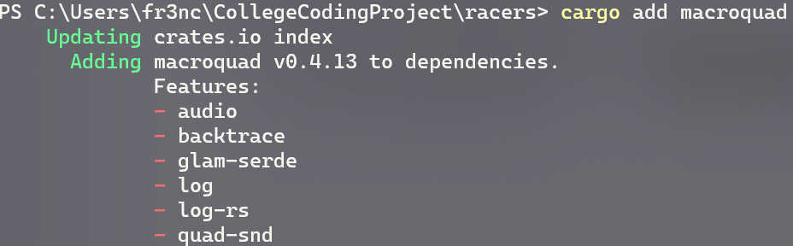

1. Build to project to fetch all the requirements from webserver

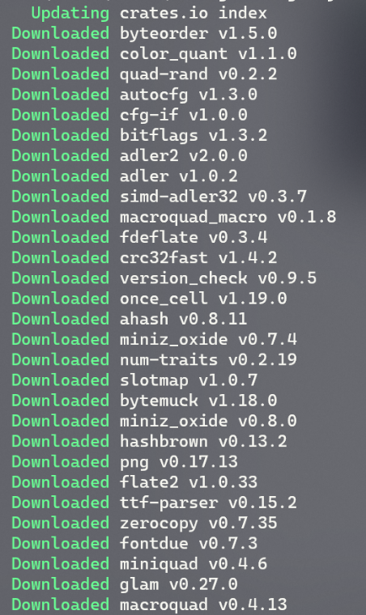

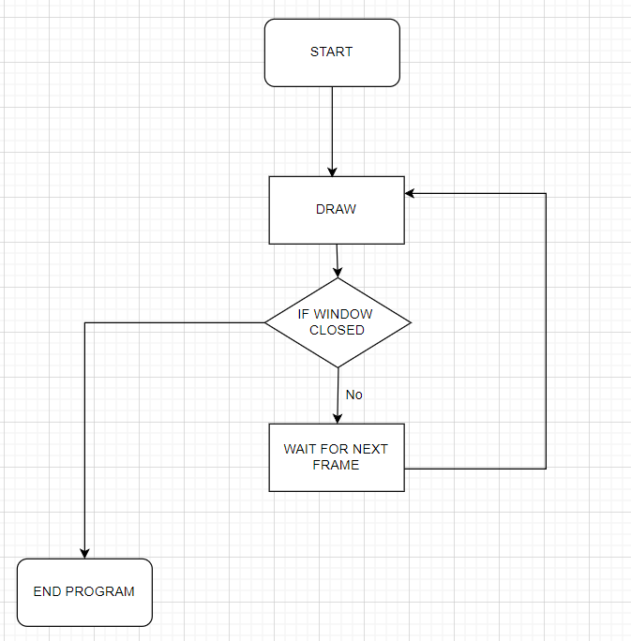Simple game loop architecture

The Boiler Plate Code

This is the code I wrote as a boiler plate which creates a window with any configuration I want. 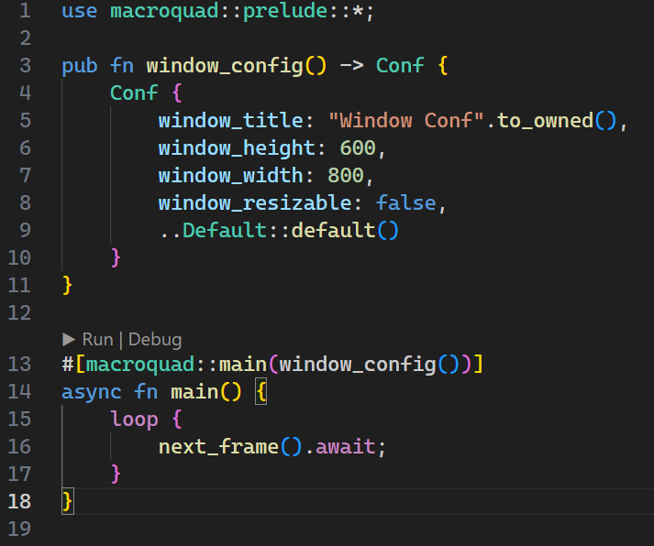

The **use** statement at the top includes most of the macroquad library into the scope of the main program. This allows me to use objects like **Conf** and functions like **next_frame()**. Also, something to be noted is that the macroquad library requires the use of a asynchronous main function to run, which is why the main function is labeled as **async.**

The **window_config()** function allows me to choose what specifications I want for the window which is displayed, for example the size at the moment would be 600px by 800px.

Now I can change the name of the widow like this:

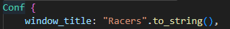

Stage 1 Conclusion – Reflect on Plan

Testing

|  |  |  |  |  |  |  |
| --- | --- | --- | --- | --- | --- | --- |
| Test No. | Description | Test Type | Test Data | Expected | Actual | Video Evidence? |
| 1a | Running the program after importing the graphics library | - | - | Should run without errors | The Program runs without any build or compilation errors  **PASS** | **Yes** |
| 1b | Testing whether window opens and closes correctly | - | - | Window should open and then can closes when **X** button is pressed | The window opened and then after a few seconds I closed it with the **X** button  **PASS** | **Yes** |
| 1c | Drawing window at specific size | - | Width = 800  Height = 600 | Window should create at correct dimensions (i.e. Should change from default size to the specified one). | The window is drawn at the correct size, and altering the width and height values changes the size of the window  **PASS** | **No** |
| 1d | Window displays correct window name | - | Name = “Racers” | The widow should display a title of “Racers” at the top | The window is created and given the correct title.  **PASS** | **No** |

**1c, 1d** – Photo Evidence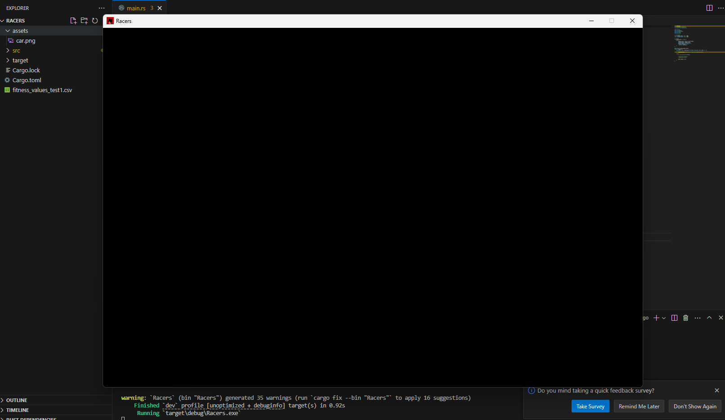

Video evidence for each test that requires it can be found under: **Documentation/Videos/Stage1Testing/[test no.].mp4**

Todo List:

* Initialise the graphics library - **COMPLETE**
* Draw window to screen - **COMPLETE**
* Allow user to close screen - **COMPLETE**
* Draw at correct size - **COMPLETE**
* Give window a name - **COMPLETE**

Development 2

*Reminder:* **Stage Two**: Create a car object and draw it to the screen. Implement movement and physics for the car: **steering angle, acceleration, speed, braking**. For development purposes allow movement to be controlled by keyboard.

**Car Object**

Outlining the object, it needs to:

* Move along the screen with velocity, direction and acceleration
* Handle its own rendering, owning its own texture
* Be able to respond to user inputs like steering and accelerating
* Facilitate the use of inputs (weights between 0.0 and 1.0) from a neural network

**NOTE**: Rust doesn’t have classes, but their **structs** are a good enough alternative, so this data is really stored in a **struct** named ‘Car’.

Explanation:

The physical quantities like **Velocity**, **direction, acceleration** and **position** are simple to understand, they are what allow the car to move around the screen any which way it wants.

The **texture** attribute is the graphic which is drawn to the screen and is how we display the cars on screen. The **rect** keeps track of the car’s hitbox so we can tell when it leaves track, hits something etc… It will also be useful in debugging in the future.

**Angle** keeps track of the angle the car is directed at (connected to the **direction**) we use the **angle** to tell the renderer how much to rotate the **texture** before drawing to the screen. **Steer** is the change in angle the **inputs** are requesting, however obviously the angle of the car doesn’t snap to its steering angle so I will use the **steer** attribute as a target for a linear interpolation.

The **Constants** are self-explanatory apart from the steer_weight which is the factor which the **0.0-1.0** **steering** **input** weight is multiplied by to get the actual angle in radians.

The inputs are basically ways of storing the output of a neural network (which should be between 0 and 1) and are multiplied by scalars later to become interpretable values. It difficult to explain and I will come to the use later, when I make the NN. I will also outline the **input** structure next.

|  |
| --- |
| Car |
| **Attributes**  + Velocity: Vector  + Direction: Vector  + Position: Vector  + Acceleration: Vector  + angle: Float  + steer: Float  +texture: Texture2D  +rect: Rect  +accelerator_input: Input  +steering_input: Input  +brakes_input: Input |
| **Constants**  + hitbox_width: float  + hitbox_height: float  + max_speed: float  + max_acceleration: float  + steer_weight: float  + max_turning_angle: float |
| **Methods**  + draw() |
| + update_pos(x, y) |
| + update() |
| + keyboard_control() |
|  |
|  |

Here is the class definition for the car object in rust:

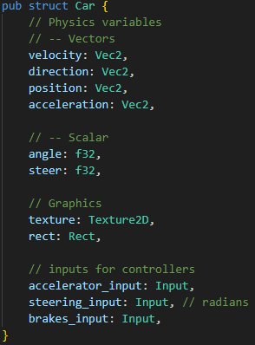

You should be able to compare this to the previously shown class diagram to spot the implementation of each attribute.

I also coded the **Car** class’s constructor, and it is very intuitive to understand, here it is:

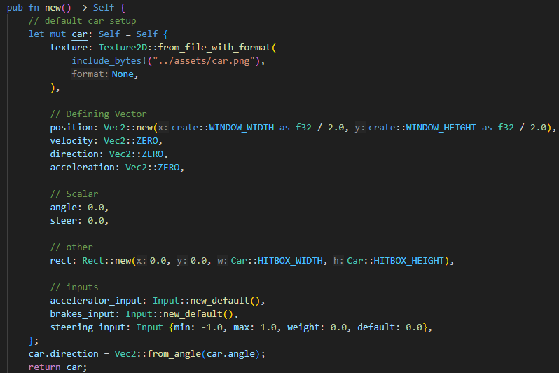

**Note**:

* I used the macroquad Texture2D structure’s functionality to import an asset I found on google for a racing car
* For now, we place the car in the middle of the screen
* We define the rectangular hitbox as macroquad’s predefined **rect** class which offers plenty of useful functionality
* The inputs are initialized as **Input** structs which are basically restricted values which can be set within a certain bound.
* We set the car direction vector by creating a unit vector in direction of the car’s angle.
* Most other physical quantities are set to zero or other arbitrary values

*Deep dive into the methods*

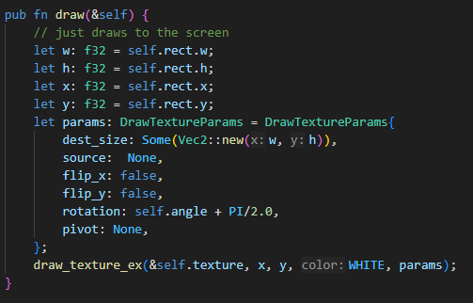

The **draw** function collects the x, y coordinates of the car’s hitbox (which is defined as a Rect class, which is a class included in **macroquad**) then it also retrieves the width and height of the hitbox. These values are passed into draw_texture_ex function which draws the car to the screen. Note we also give the function parameters for rotation since the car should rotate on the screen, but we have to offset the rotation by PI/2 radians or 90 degrees to account for the sprite being at a 90-degree angle. Apart from that it’s a pretty simple function.

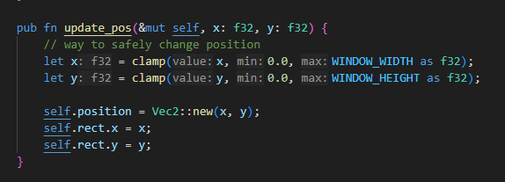

The **update_pos** function takes 2 new coordinates to set the car’s position to, its essentially a *setter*i.e. an public interface to the class’s attributes. It also serves the function of clamping the car to the screen and updating the car’s hitbox **rect** as well as its actual position vector.

**Update** Function

The update function is the main function which controls the behaviour of the car’s physics. It should apply all the physics onto the car object like acceleration, velocity, friction, update position and steering. The steering is the most complex part of the algorithm so I will go into more detail on that.

My update function algorithm in broken English code:

Function Update()

Calculate delta time, to apply to all physical calculations

Calculate how much to steer car

Add steer delta to car’s angle

Calculate new direction vector for car

Calculate car’s acceleration from accelerator input and set its direction to the car’s direction vector

Add velocity to the cars position vector

Update the car’s position using the method

End of function

My update function algorithm pseudo code:

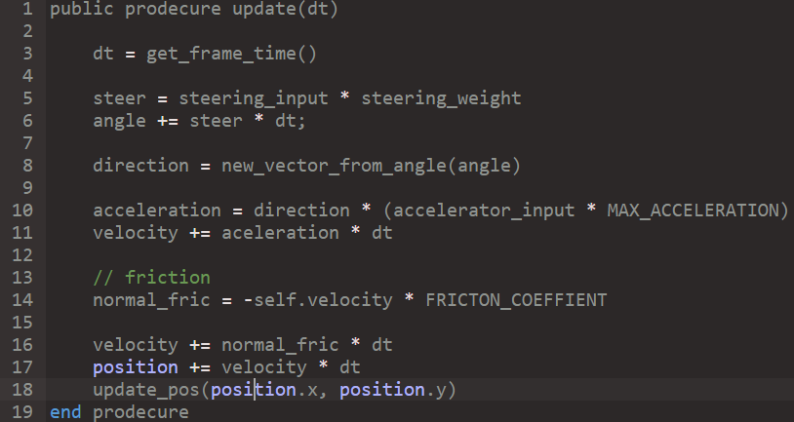

After planning the method in pseudo code I wrote it in rust, note that the key difference between the rust code and the pseudo code is that we need to call methods and attributes using the **self**-keyword and a few variables are given slightly different names for cleaner code. Here it is:

Rust code:

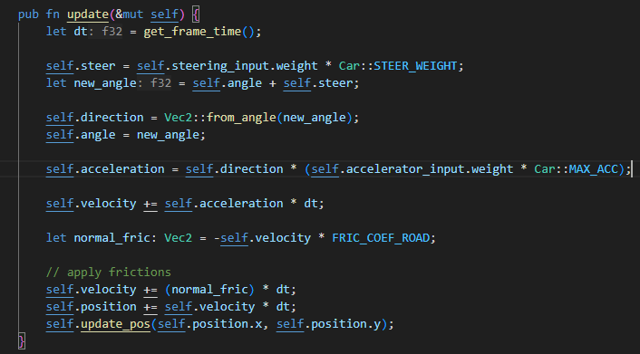  
For now, this update code should be robust enough, however I fully anticipate modifying this function **a lot** since it contains the main bulk of the car’s physical code.

Modifying the Main function

Now we have created the blueprint for a car object, lets create one and update and draw it from the main function.

**Note**: I aim to have only 2 public interfaces to the car class (apart from its creation), which are the **update** and **draw** functions. i.e. the only functions which should be called on the class from outside of itself are the **update** and **draw** functions.

Here is the pseudo code and real code for the main function.

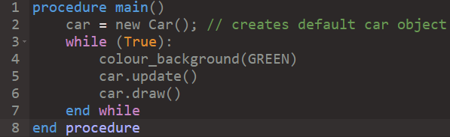

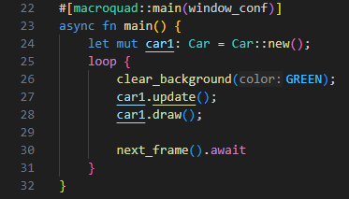

**Note:** The rust code is slightly different, but its just rust’s weird implementation of an infinite loop, and the first scary line is just a bit of macroquad boiler plate (since macroquad requires asynchronous rust to be enabled to run).

Also, I’m fully aware that the main function will change a lot during development and this version is very temporary and mainly for development purposes, but I think it’s important to show what it looks like now since its really the foundation of the project.

*Finally, the user input*

After staring at a stationary car on the screen for a while, I realised that I wanted to implement a way for a **human** user to interact and control the car. Although the car’s will eventually be fully controlled by **AI,** I need to be able to test out the physics before moving onto that implementation, thus *user input* needs to be implemented.

Since its quite an intuitive and temporary method I won’t go into huge detail on it and I will give it to you in rust code:

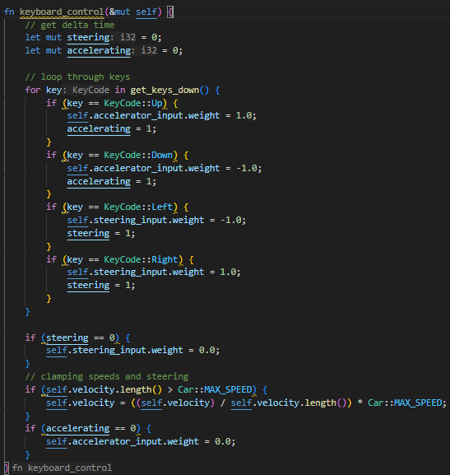

Essentially, for now we are imitating the eventual **neural network’s** inputs using the keyboard for development purposes. Also note that we have two Boolean variables called ***steering*** *and* ***accelerating***which indicates whether the accelerator (forward key) or the steering keys where pressed and if they weren’t set the inputs to **zero**.

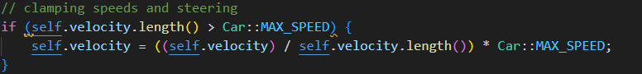

And this section of code caps the speed of the velocity to the car’s predefined max speed.

Now we are ready to test the car physics

Let’s add the user input method into the **update** method

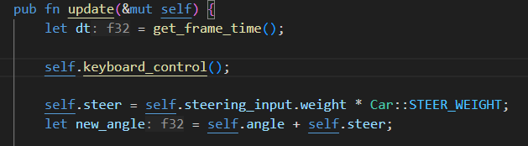

And run the code…

When I ran the code, I noticed that the car would spin instantly when the arrow keys were pressed instead of smoothly rotating, so I added a linear interpolation function to smooth out the rotation.

***The Fix***

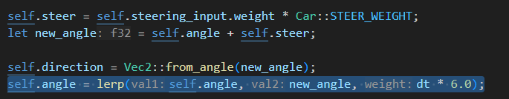

The highlighted line is the modified line. The linear interpolation function requires a factor to say how fast the value should reach the target value, with a bit of tweaking I found that using **deltatime * 6.0** was a good factor for smooth steering.

The video of the running car physics is in “**videos/s2-carrunning.mp4”**

**Link: (**[**Videos\s2-carrunning.mp4**](Videos/s2-carrunning.mp4)**)**

The final thing missing now for the car physics is a braking system. The car should take its braking input and transfer it into a force opposing the car’s motion.

Formula

The brake mechanism will be another frictional component to negate velocity, so we will use a formula which creates an opposing braking frictional acceleration.

**Brake_friction = -velocity * brake_input * brake factor**

The brake factor is a variable used to tweak how powerful the frictional force on the velocity is.

The code:



The result:

[Videos\s2-braketest.mp4](Videos/s2-braketest.mp4)

Testing Stage 2

|  |  |  |  |  |  |
| --- | --- | --- | --- | --- | --- |
| Test no. | Test Description | Test Data | Expected Result | Actual Result | Pass |
| 2.a | Test keyboard input accelerate and friction |  | Press w key and the car will accelerate in the direction of the sprite | It does accelerate and friction eventually brings the car to a stop | Checkmark with solid fill |
| 2.b | Test steering |  | Press a key and the car steers left **only** when moving. And visa-versa for right key. | The steering works as expected, turning its velocity and rotation of sprite | Checkmark with solid fill |
| 2.c | Test braking |  | When the s key is pressed **and** the car is moving, the car’s velocity should close to a stop | The car does brake when the s key is pressed, it slows down quite slowly but the feature does work | Checkmark with solid fill |
| 2.d. | Car sticking to screen |  | When the car hits the border of the screen it should be blocked as if it has hit an invisible barrier | The car does stop but doesn’t act quite as expected, the car sprite can go fully off the screen on the rhs of the screen but on the lhs of the screen it stops as expected. | Close with solid fill |

Results:

The program passed ¾ tests which is a solid result, the failed test is quite an easy fix. Here’s the current code:

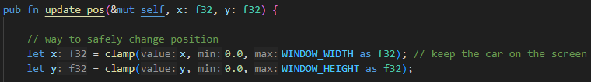

The problem is the sprite’s position is the top left corner of that sprite:

Width = w



Pos (x, y)

Height = h

The solution:

Pseudo Code

pos.x = clamp(0, ScreenWidth - w)

pos.y = clamp(0, ScreenHeight - h)

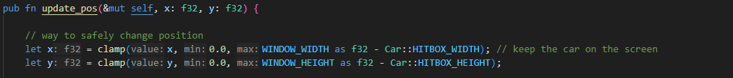Rust Code

Development Stage 3

Recap

**Stage Three:** Create a *track* object which handles track limits, drawing itself and checkpoints (which divide the track into sectors)

What is a track?

I think a track object can be defined by a series of points and then we can connect them with lines. To make it look more like a standard track, we can then draw these lines with a large thickness (thickness = road width)

1. Series of dots

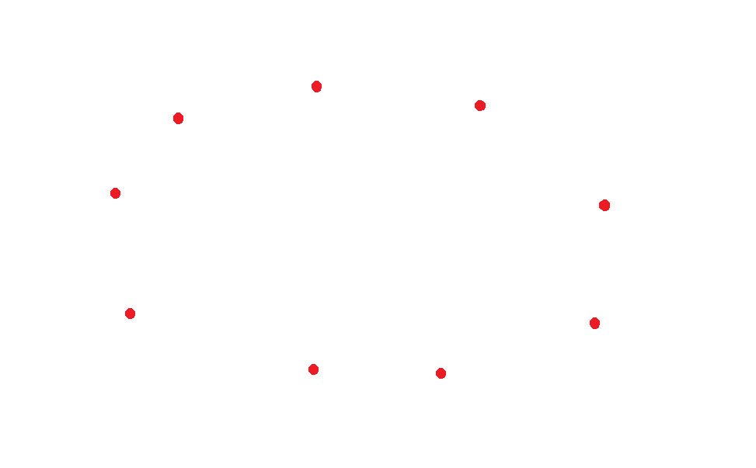

1. Connect the dots

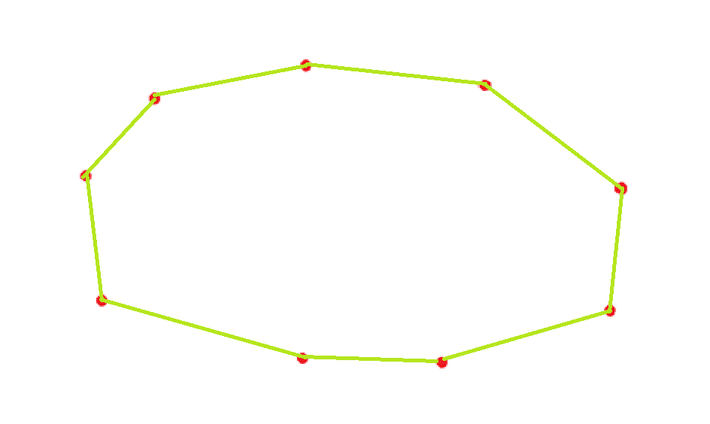

1. 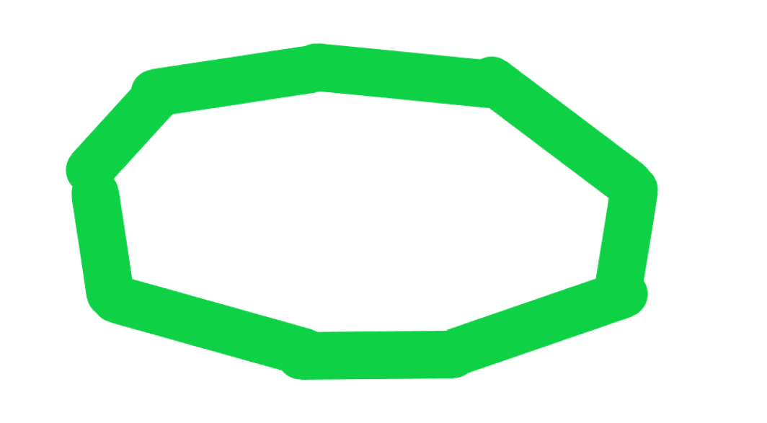Thicker line

I made a little animation in python to visualise and wrap my head around how this would work. The file can be found in

**Documentation/Videos/TrackDemonstrationVid.gif**

So now I know what to do, however to define a track as a set of coordinates we need to know the size of the screen, which we should keep as a constant throughout the project.

These values are predefined in the main.rs file but let’s reiterate them in this document.

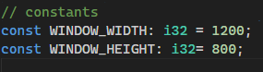

So, our track must lie in a plane of pixels **1200** wide and **800** high.

In this stage of development all I need to do is create a track object so we will save the potential random track generation for later. For now, I will predefine a test track with a set of coordinates.

I think a set of 20 points should be able to define any track I will ever make so I chose the set of points to be an array with size **20.**

|  |
| --- |
| Track |
| Attributes:  + points_set: int[2][20] |

Current Track class diagram

I created a test track in paint and copied the coordinates into my track.rs file as a constant array.

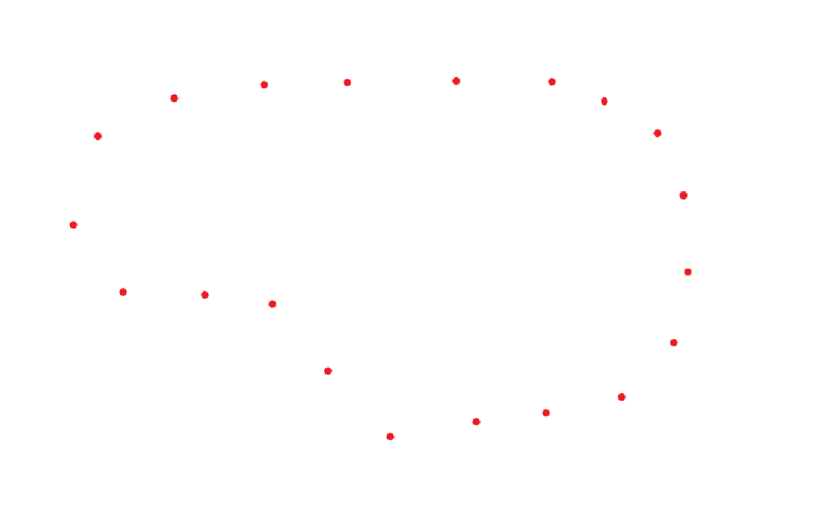 **Test Track 1:**

**Code defining the track**

track.rs

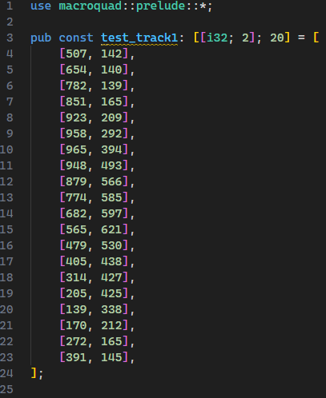

Designing Track Object

Now we have a way of defining a track lets design the class around it.

**The rust structure in code based off of the class diagram from previous page:**

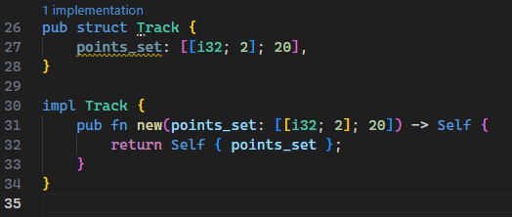

The first functionality I can think of is **drawing the track** so let’s design that function.

**The algorithm**

In English the draw algorithm needs to loop through the set of points, draw lines between them of a given thickness (track width) making sure to draw a line between the first and last points. That is the beauty of it, it should be simple.

**Pseudocode**

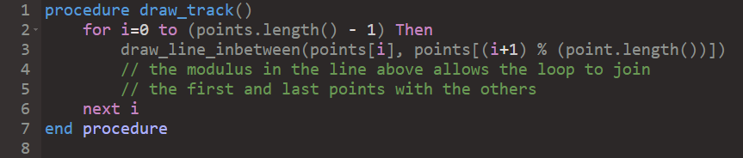

The only bit of complexity here is the modulus described in the code above. It basically means that when the variable **i** reaches the final index of the array **i+1** will loop back to **0,** which essentially means that when the loop finishes it will have joined the first and last point as well as all the others.

When writing the **rust** code, I had to search up how to use a **for loop** in rust and found the answer on [https://doc.rust-lang.org/reference/expressions/loop-expr.html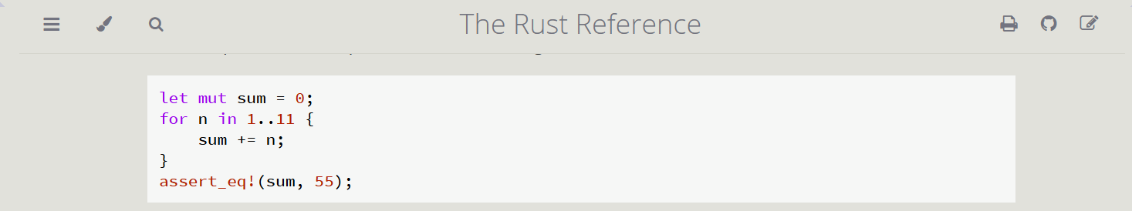](https://doc.rust-lang.org/reference/expressions/loop-expr.html)

Importantly, the range **1..11** loops through 1 to 10 so it’s **not** inclusive on the upper end.

**I also had to look up the draw_line function in macroquad docs:**

<https://docs.rs/macroquad/latest/macroquad/shapes/fn.draw_line.html>

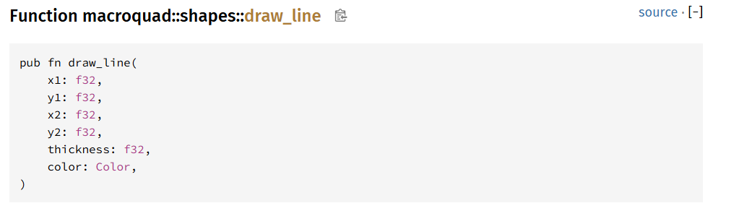

Rust code:

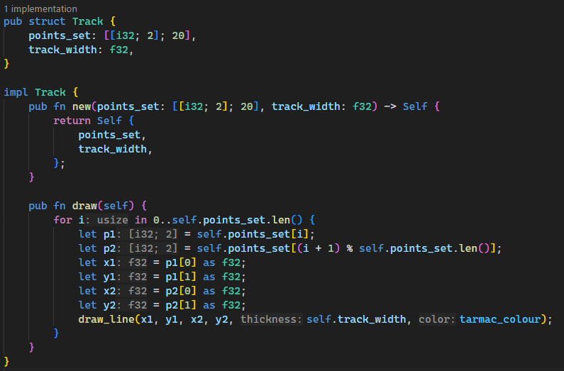

You may notice a new class attribute **track_width** which I added to the track class as a float value. I also added it in the constructor function. Also, I added a constant tarmac colour at the top of the program here:



Updated class diagram

|  |
| --- |
| Track |
| Attributes:  + points_set: int [2][20]  + track_width: float |
| Methods:  + public procedure draw() |

So, I added a new track object to the main file and called its **draw** function in the main game loop: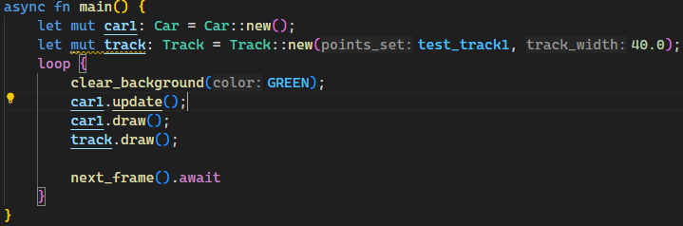

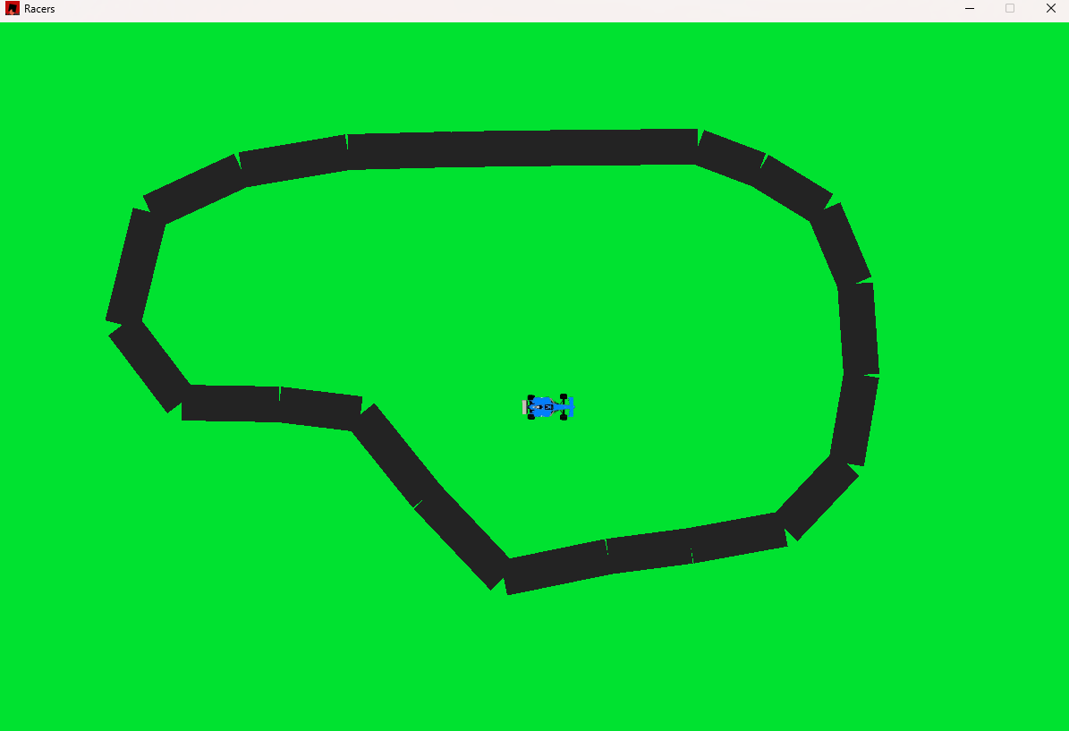However, when I ran the code it was clear something was a tiny bit off:

The lines are draw like rectangles when ideally they would be drawn as a line of circles, (Ill implement that now) and the trackwidth is a bit too small so I just needed to tweak that in the class initialisation line from 40px to 75px.

The bespoke draw_line function I wrote in rust:

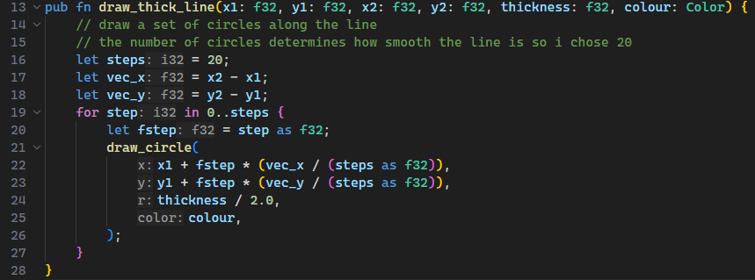

***What it does:***

1. Calculates the vector (x and y components) from the first point to the second point
2. Loop through all steps and draw a circle at a point which is calculated by **the original point + a step through the vector**
3. Draws all 20 circles and then terminates

I made sure to use the same number and order of arguments as the **macroquad** library **draw_line** function so that I could easily switch between both.

Here is the new draw_**thick**_line function used in the **track.draw()** method:

**

*The commented-out line is the previous draw_line library implementation*

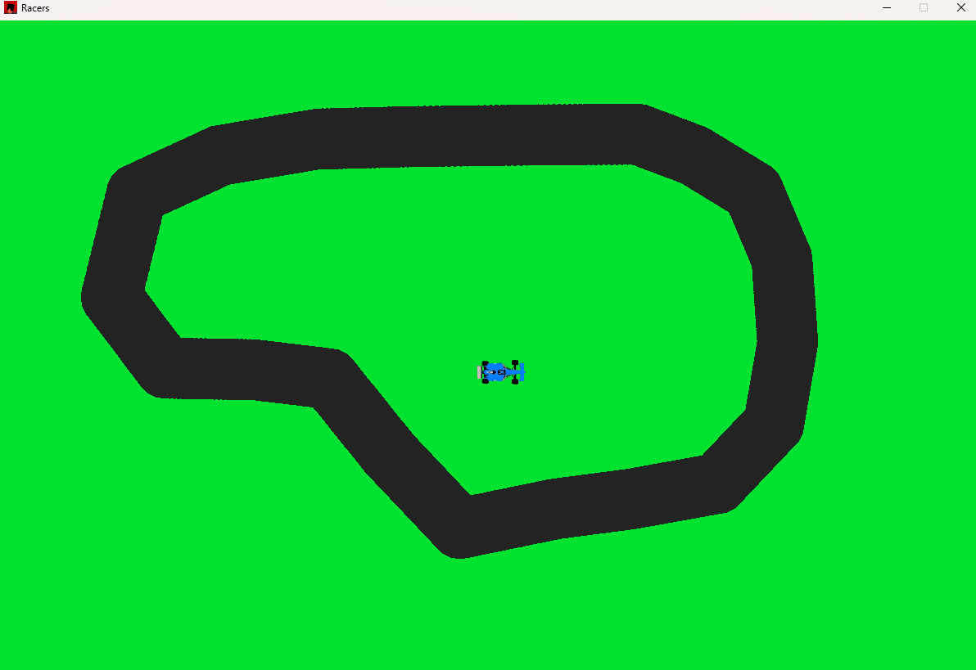The new result

Now that we have drawn quite a beautiful looking track now we can implement the checkpoint system.

**My idea:**

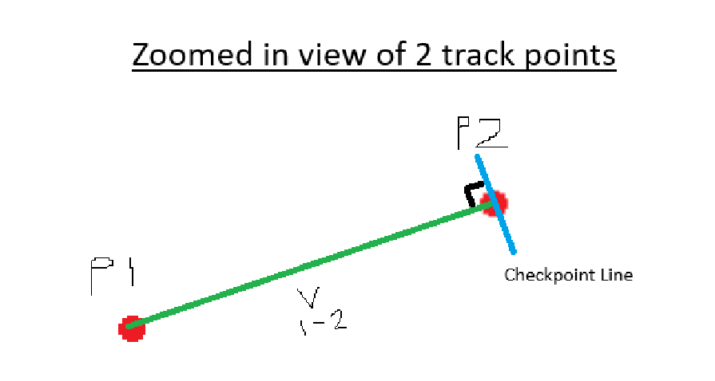

The diagram shows 2 adjacent track points and where the checkpoint line should be drawn. As you can see the checkpoint line is perpendicular to the vector line joining previous point (p1) and the current point (p2).

So, the direction of the checkpoint line can be calculated using some maths (which consequently I have been learning in further maths a level recently).

**Let P2 = (x2, y2)**

**Let P1 = (x1, y1)**

**∆x = x2 – x1**

**∆y = y2 – y1**

**The normal vector is (-∆y, ∆x)**

So now we have an expression for the normal vector direction. However we need to limit its length to **track_width**.

**Let normal vector = n**

**Checkpoint Vector = n/|n| * track_width**

The n/|n| is the normal vector divided by its magnitude creating a unit vector in the same direction. Multiplying that by the track_width will give you an aptly sized vector.

Pseudo code

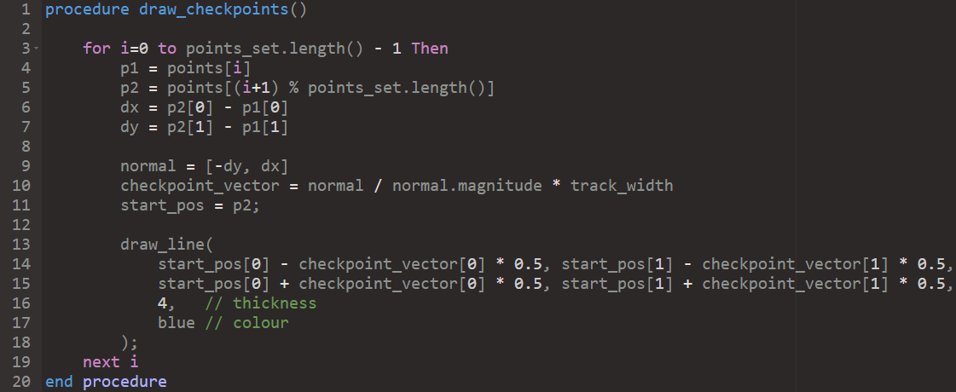

After writing this I decided to rewrite some of the track code to use a predefined struct called Vec2 which stores a x and a y component, rather than using an array of length 2 because it would make the code much more readable. The Vec2 object also provides some useful functionality which I would have otherwise had to write myself.

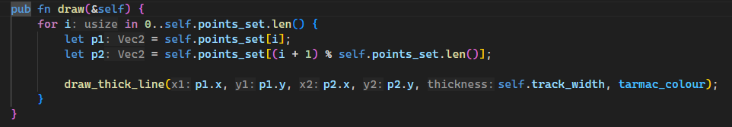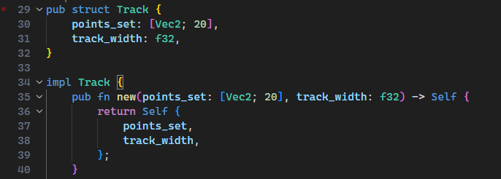

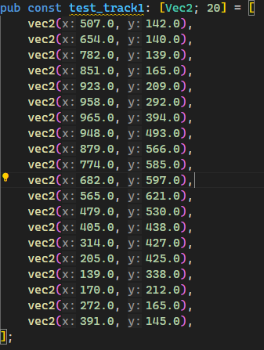Also, a Vec2’s components are float types by default so much of the messy code in the previous draw function can be removed. Overall, changing to this data type will make my code base much more organised. Also note that the new class diagram attribute section looks like this:

|  |
| --- |
| Track |
| Attributes:   * + - points_set: Vec2[20]     - track_width: float |

Finally, the draw checkpoint method implemented in rust:

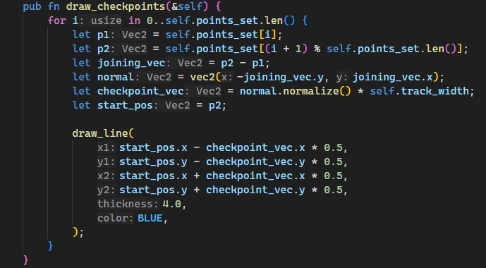

Now let’s run and see the result:

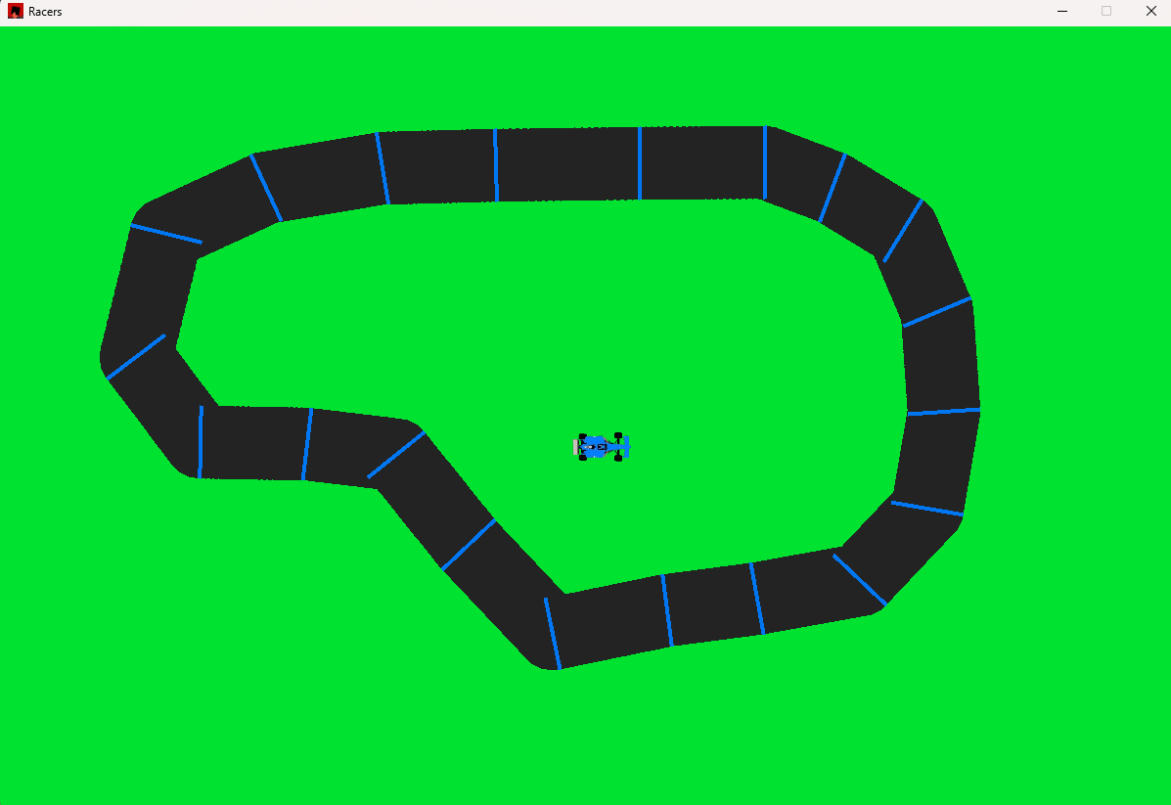

The checkpoint lines are drawn correctly with a little inaccuracy in some places where the line doesn’t quite make it to the other side of the track.

Its going to be pretty impossible to make it completely perfect due to the inaccurate nature of drawing the lines as circles, however I have an idea to increase the accuracy of the lines drawn.

The premise

It works by taking into account the next point in the set of points as well as the last one, calculated both the normals and taking an average of the 2 to create the new line:

Ill just provide the rust code since its quite an intuitive addition:

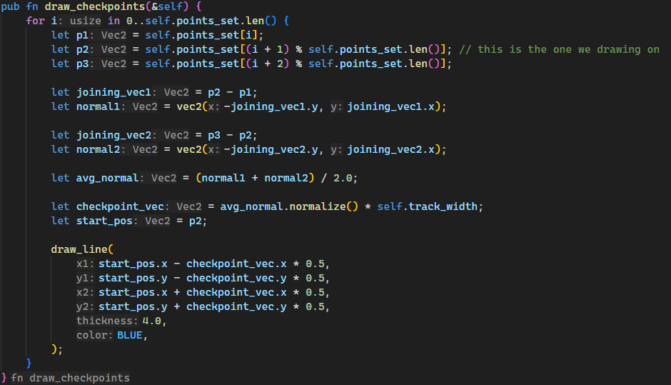

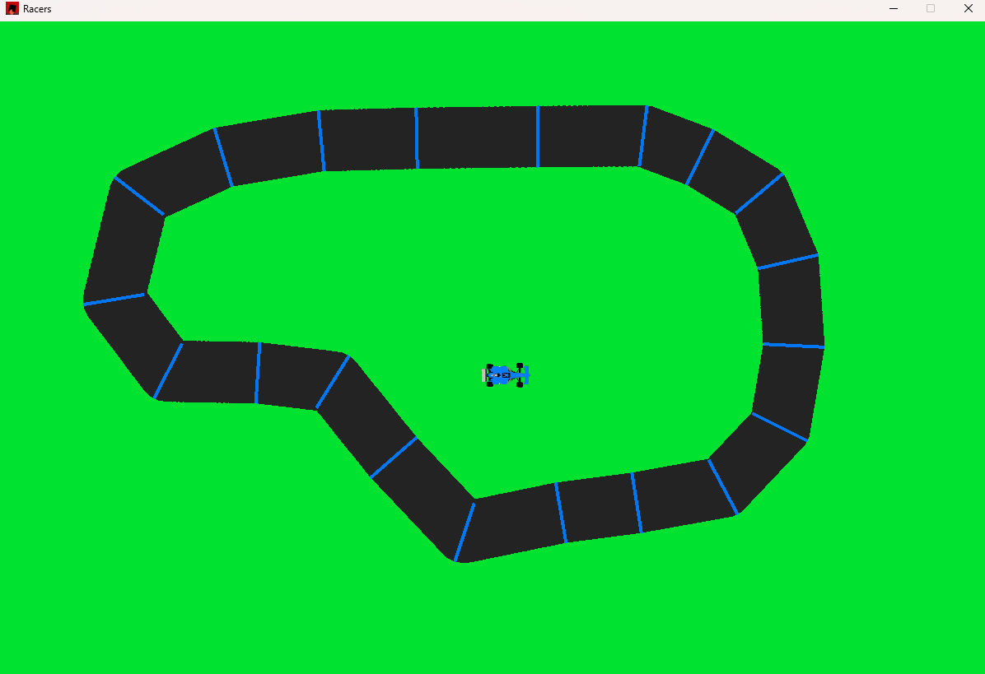The result:

**Clearly much more accurately drawn checkpoint lines now!**

Now the checkpoint drawing function is complete and should be added to the track main **draw** function

When testing this, the car appeared to be underneath the track, suggesting it must be being drawn before the track, when the car should be drawn after the track.

Real time footage of this incident can be found in

*Documentation/Videos/carGone.mp4*



I fixed this and driving on the track footage can be found

*Documentation/Videos/DrivingOnTrack.mkv*

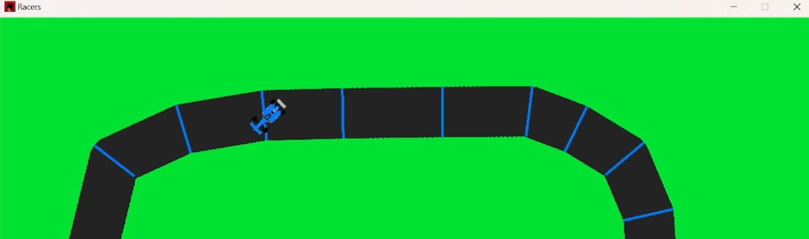

Track limits

To handle track limits, I have decided that an effective solution will be to check if the centre of the car’s hitbox is outside the track. Ie. It the location of the centre of the hitbox is further than **(track_width / 2)** away from its **sector line**. The **sector line** is the straight line which connects the 2 track points the car is in between.

*Diagram* 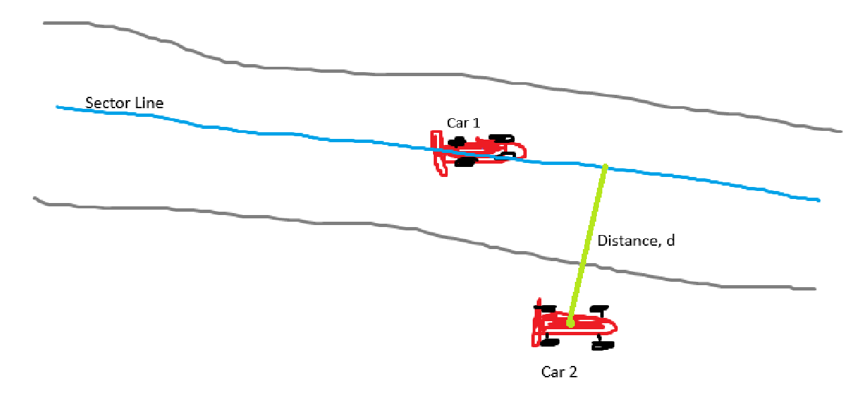

*As you can see the Car 1 is pretty much on the sector line so its definitely inside the track however Car 2 is off the track because the distance from the sector line to its centre is greater than the track_width.*

To actually implement this, we want an **is_on_track** method attached to the **Car** object which can access the **Track** object.

My idea is to have the is_on_track function take a reference to the track object, then the car methods take over the algorithm, they should identify which sector the car is on (closest to) and then further calculate whether the car is on or off the track in the sector.

So, decomposing the problem we need:

* A function to obtain the current sector
* A function to calculate distance to the sector line

*Step 1)*

The **get_sector** functionality for the car given the track object as a reference

The outline of the function is as follows



***Note: The sectors should be numbered 0-19 where sector 0 is the sector between trackpoints 0 and 1, and sector 19 is the sector between points 19 and 0.***

How to do it:

For every sector

* Find the midpoint between the 2 points which define the sector (i.e. if we are on sector **1** then we look at the points **0 and 1.**
* Calculate distance between car’s centre and the midpoint

The sector which gives the shortest distance is the current sector

Implementation

First, I created a getter function which returns a reference to the **Track’s** points_set attribute

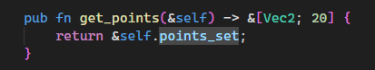

Then I wrote the **get_sector** code.

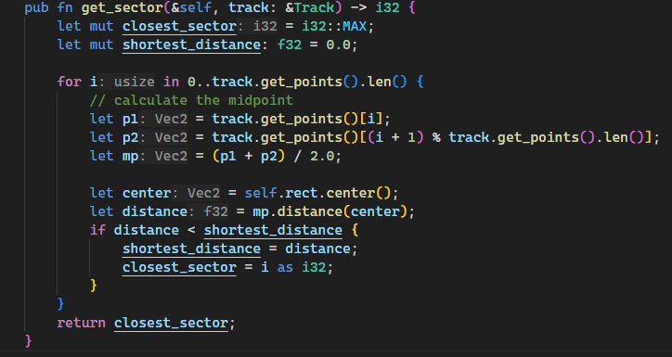

To test the code, I ran it with a print message as shown

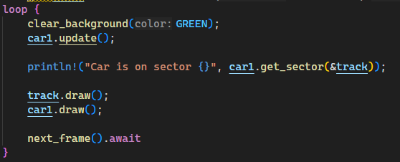

*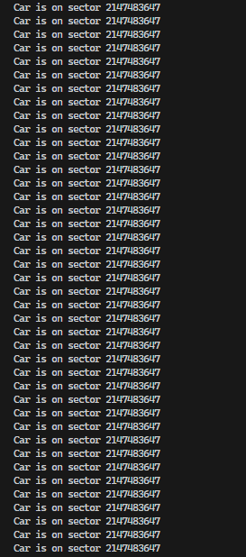However,* ***this*** *was my terminal:*

Clearly this is not a correct result, however when I inspected the function again I realised a simple error in the code

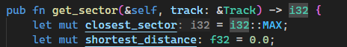

I mixed up the top two variables, the closest_sector should be **0** at default and the shortest distance should be at **f32::MAX** – which is the *largest possible 32-bit float* - at default (it should be as large as possible so any other distance will override it).

I swapped those values around and now the fixed code looks like this

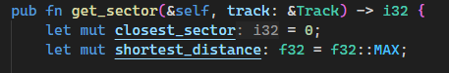

I also decided to highlight the car’s sector to make it easier to understand the output of the function.

After fixing a few silly errors the system worked great! The running video of this working can be found in:

*Documentation/Videos/SectorHighlighting.mkv*

Step 2)

*Finding distance to the sector line*

The only tough bit about this is the calculation to find the perpendicular distance from a line (vector) to a point. However, there is a pretty simple formula to compute this distance, I found this formula on [brilliant.org/wiki/dot-product-between-point-and-a-line](https://brilliant.org/wiki/dot-product-distance-between-point-and-a-line)

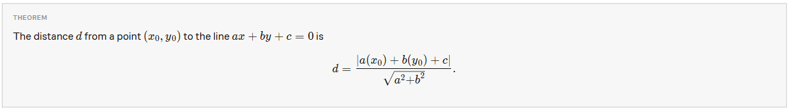

To find the equation of the line of the track sector we need to make a new function which takes in the two points calculates a gradient and finds the values of **a, b and c** in the formula above. To make computing this easier let’s say that **b** is 1 so we just find an equation in the form

y = mx+d

and then rearrange it, to find **a and c**. This means that **m** is the gradient (which is easy to compute) and then we can find **d** using simple maths.

*Pseudocode of this:*

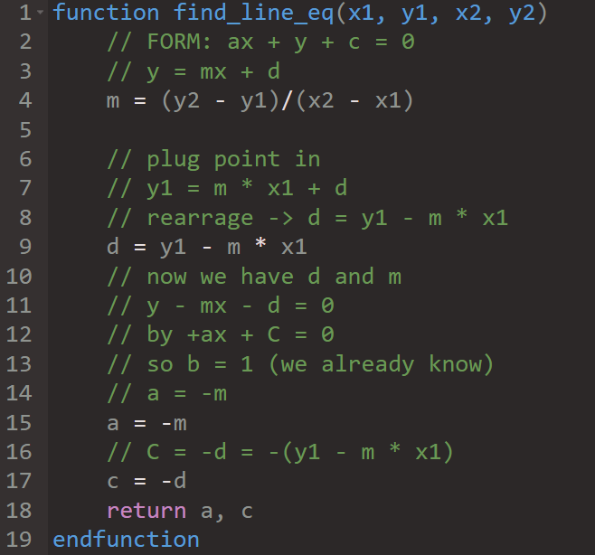

The maths is very simple but I tried to comment it in any way to explain my thought process to myself.

Here’s the function now converted to rust:

Note: I put useful global function like this into a file called utils.rs so that they exist in their own section of the code base in order to declutter the main files.

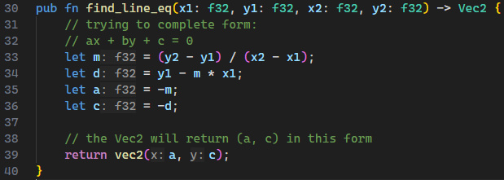

Testing this function

Test Data, Expected result, actual result

|  |  |  |  |
| --- | --- | --- | --- |
| Test Data | Expected Result | Actual Result | Result |
| (3, 5), (4, 6) | A = -1, C= -2 | A = -1, C= -2 | **Pass** |
| (-5, 2), (19, 20) | A = -0.75, C=-5.75 | A = -0.75, C=-5.75 | **Pass** |
| (0, 0), (0, 0) | A = NaN, B = NaN | A = NaN, B = NaN | **Pass** |

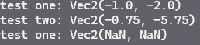Output ->

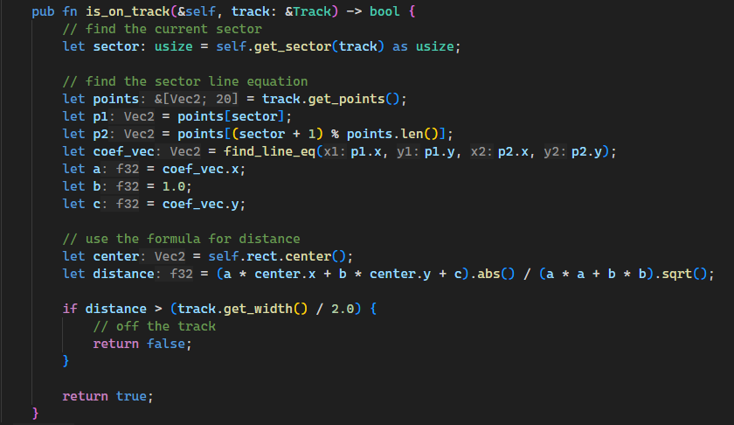 Now it’s safe to use it in the main **is_on_track** function. Now we can find the perpendicular distance from the centre of the car to its nearest sector line so we can write the whole function:

I also had to add another getter for the track object, **get_width()**:

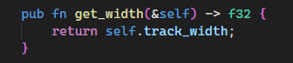

Now I will add a print alert to show whether the car is on or off the track and run the code!



The function worked perfectly (which really surprised me) and the footage can be seen in:

*Documentation/Videos/TrackLimitTesting1.mkv*

Finally, I removed the temporary code which highlights the sector that the car is on and I tweaked the tarmac colour to be slightly lighter as well as the checkpoint colour.



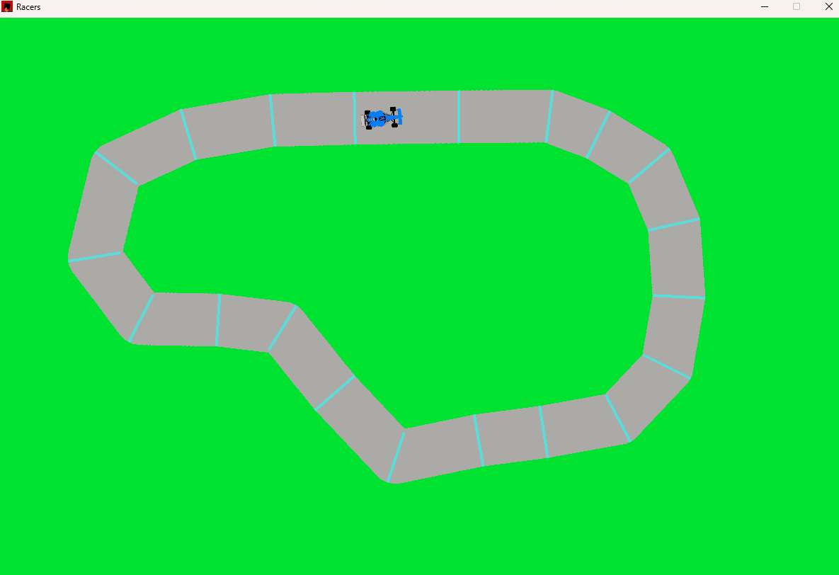

Stage 3 Testing

|  |  |  |  |  |  |
| --- | --- | --- | --- | --- | --- |
| Test Name | Description | Test Data | Expected Result | Actual Result | Result |
| 3.a | Boundary test for get_sector function | Place car in the top right of screen | The function should return sector number **17** | The output was sector number **17** | **PASS** |
| 3.b | Boundary test for get_sector function | Place car in bottom right of screen | The function should return sector number **7** | The output was sector number **7** | **PASS** |
| 3.c | Full test of **track limit detector** | Drive all around the track both on and off | When the car’s centre is visibly off the track the return value of **is_on_track** should be false. When it is on track the return value should be true. | The function results coincided exactly with what was visible on the screen. I found no unexpected results. | **PASS** |

|  |  |
| --- | --- |
| Test Name | Evidence |
| 3.a |  |
| 3.b |  |
| 3.c | Screen recording found *Documentation/Videos/testing3c.mkv* |

End of stage 3

Now we are at the end of development stage 3, before I move onto the next stage I want to re-create the respective class diagrams for my structures.

|  |
| --- |
| Car |
| **Attributes**  + Velocity: Vector  + Direction: Vector  + Position: Vector  + Acceleration: Vector  + angle: Float  + steer: Float  +texture: Texture2D  +rect: Rect  +accelerator_input: Input  +steering_input: Input  +brakes_input: Input |
| **Constants**  + hitbox_width: float  + hitbox_height: float  + max_speed: float  + max_acceleration: float  + steer_weight: float  + max_turning_angle: float  + mass: float  + braking_factor: float |
| **Methods**  + draw() |
| + update_pos(x, y) |
| + update() |
| + keyboard_control() |
| + get_sector() |
| + is_on_track() |

|  |
| --- |
| Track |
| **Attributes**:  + points_set: int [2][20]  + track_width: float |
| **Methods**:  + draw()  + get_points()  + get_width()  + draw_checkpoints() |

Development Stage 4

Recap

1. **Stage Four:** Implement the backend for neural networks, including **matrices, matrix operators,** and a ***network* object** which keeps track of **layers, weights** and allows easy abstraction from the inner complexities.

Before attempting to design or write this part of the project I did some extensive research into neural networks, and the implementation of them in various programming languages. Using the following sites:

<https://www.digitalocean.com/community/tutorials/constructing-neural-networks-from-scratch>

<https://towardsdatascience.com/math-neural-network-from-scratch-in-python-d6da9f29ce65>

The second article was particularly helpful (I just read around the bits about back propagation since the genetic learning algorithm doesn’t require this).

The Network Architecture

The idea is to have a parent Network class which you can construct by adding layers to it (being able to specify the number of inputs and outputs, and the activation function if its an activation layer). Then we can feed input data into the network and the network will run a forward pass and return the set of output values, the data flows layer by layer until it reaches the output layer.

Run

Add Layer

Network Object

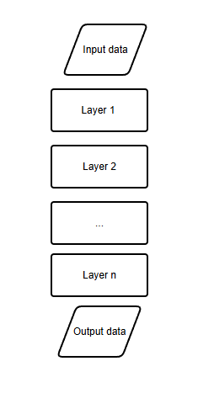

Using this design, it will be easy to tweak the network structure of the AI controllers without rewriting parts of the class.

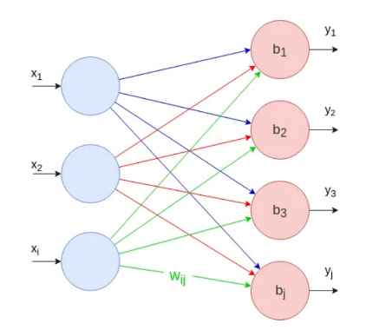

Types of Layers

* **Fully connected layer** – a layer of **n** neurons, where every neuron is connected to every other neuron in the next layer.
* **Activation layer** – a layer which applies a given **activation function** (usually an exponential function) to each input neuron.

Fully connected layer diagram from <https://towardsdatascience.com/math-neural-network-from-scratch-in-python-d6da9f29ce65>

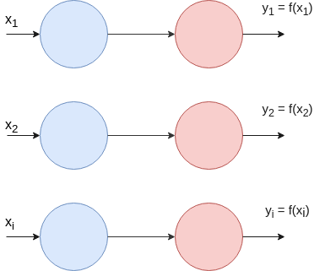

A diagram of an activation function from <https://towardsdatascience.com/math-neural-network-from-scratch-in-python-d6da9f29ce65>

Implementation

A fully connected layer needs to have a set of weights, and biases. During forward propagation an output neuron’s value is calculated by summing the product of every input value and its respective weight value and then adding the constant bias.

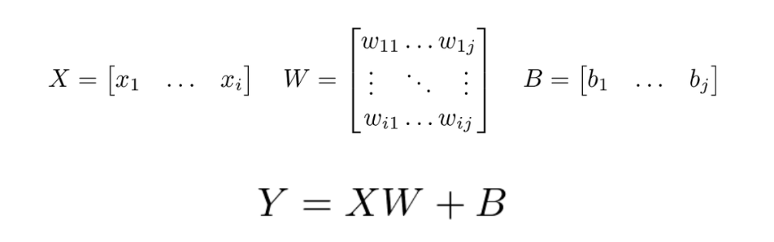 Using linear algebra, you can carry out the process in one big matrix calculation as follows:

Figure - [https://towardsdatascience.com/math-neural-network-from-scratch-in-python-d6da9f29ce65](%20https:/towardsdatascience.com/math-neural-network-from-scratch-in-python-d6da9f29ce65)

And this is what we will compute in our program.

**Network Class**

|  |
| --- |
| Network |
| Attributes:  + layers: Layer |
| Methods:  + public add_layer(layer)  + public run(inputData) |

I’m going to place the neural network code in a new file called network.rs

Network class:

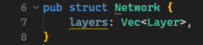

Constructor:

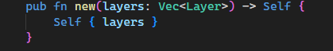

The network class will intialise as an empty list of layers, and then I can add layers using the **add_layer** function.

Note: The matrix in the calculation will be structured in the rust **vector** data type. A 2D **vector** will define a matrix and a 1D **vector** will define a column vector.

**Layer Class**

|  |
| --- |
| Layer |
| Attributes:  + weights[]: float  + bias[]: float  + activation: **function** optional  + outputs[] float optional |
| Methods:  + public calculate(input[] float) |

Layer class:

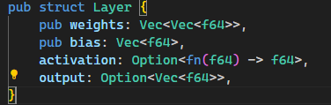

Layer constructor: 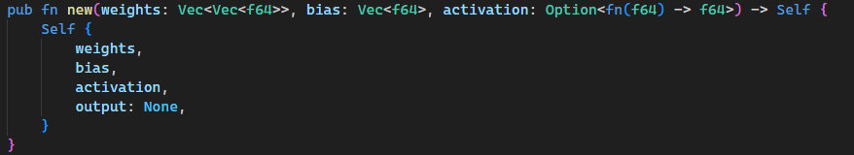

The layer calculation:

Psuedo Code

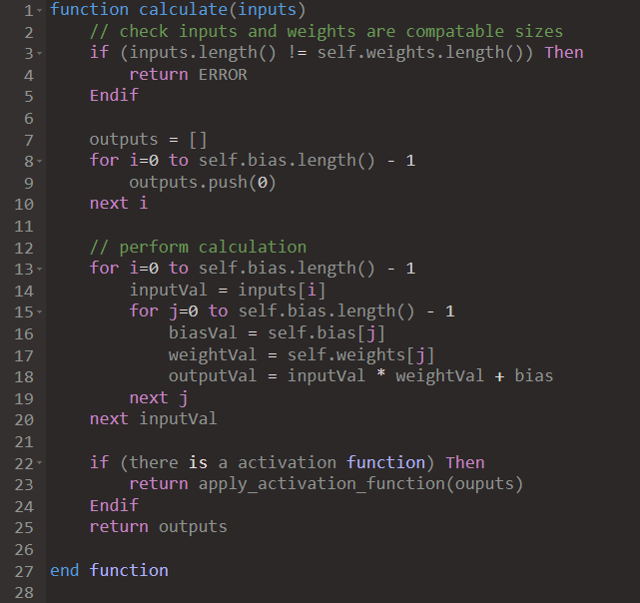

The whole network pass algorithm

Psuedo Code

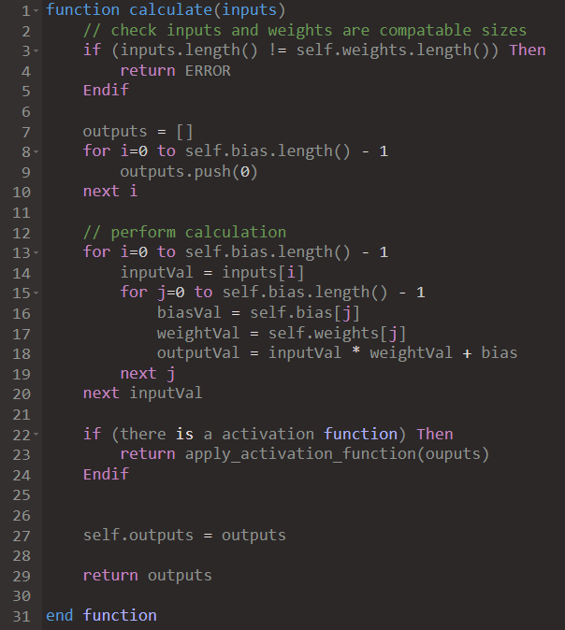

Note: in line **27** the output values of the layer are saved to the layer object so it can be used later.

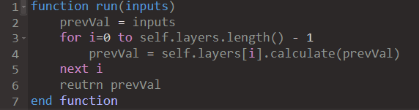**The pseudo code for a network pass**

Now I can write the code in rust:

The layer calculate code:

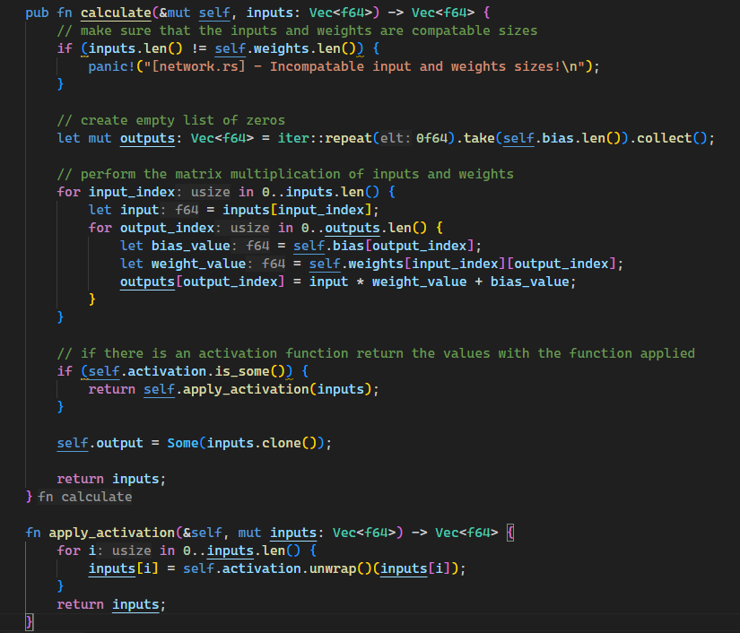

The Network pass code

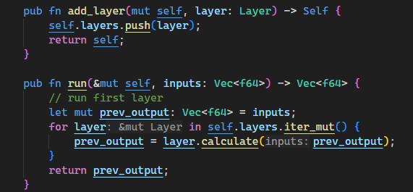

Finally, I will add my chosen activation function – the **sigmoid** function. The **sigmoid** function is a nonlinear activation function defined as the following:

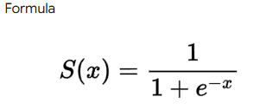

This should be easy enough to program into a function in rust:

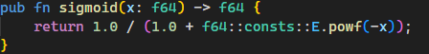

Let’s test the network code in isolation first:

1. Create a network with 2 layers, the first with 3 neurons and the second with 2 neurons. Only the second layer is to have a **sigmoid** activation function
2. Provide layer 1 with respective weights and biases:

* Weights: [[0.5, 0.25, 0.9], [0.1, 0, -0.1], [1.0, -1.0, 0.2]]
* Biases: [1.0, 4.0, 1.0]

1. Provide layer 2 with respective weights and biases:

* Weights: [[0.1, 1.0, 0.1], [0.5, -0.5, 0.0]]
* Biases: [10.0, 0.0]

1. Give the network the inputs [2.0, 1.0, 3.0]
2. What are the expected results?

I calculated them on my white board and found that the output values after the first layer should be:

 **[4.95, 3.9, 2.6]**

But I kept getting this output

I realized that this logic bug must be caused somewhere in the **calculate_layer** code and I found that I wrote this

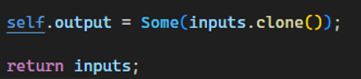

Clearly, I mixed up the **inputs** and **outputs** variables, so the network was just redistributing the input matrix rather than actually passing along the calculated outputs. I quickly fixed that and now the output is:  which is again incorrect, so I need to have another look at the calculation code for errors.

Looking at the previous code, I think the input index and output index were mixed up, I rewrote the code:

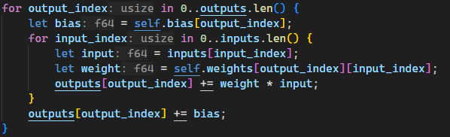

To see if this solution would work, I drew a trace table for the first calculation:

|  |  |  |  |  |  |
| --- | --- | --- | --- | --- | --- |
| Output Index | Input Index | Bias | Input | Weight | Output |
| 0 | 0 | 1.0 | 2.0 | 0.5 | 1.0 |
| 0 | 1 |  | 1.0 | 0.25 | 1.25 |
| 0 | 2 |  | 3.0 | 0.9 | 4.95 |

The trace table showed that the logic was correct and the code should work, I ran the tests again with the new code and got the correct results:



1. Now what are the expected results for the final output layer:

* So, the inputs to the final layers are [4.95, 3.9, 2.6], then we apply the weights [[0.1, 1.0, 0.1], [0.5, -0.5, 0.0]] Which gives us the matrix [4.655, 0.525] Then we apply the bias values [10.0, 0.0] to get [4.655, 0.525]. Then we finally apply the activation function to get [0.9906, 0.6283]

However, after I got a wrong result, I looked over the code again and found this bug

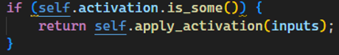

Instead of applying the activation function to the output values this snippet of code applies it to the input values which is redundant. I fixed that and now the program spits out the correct value:



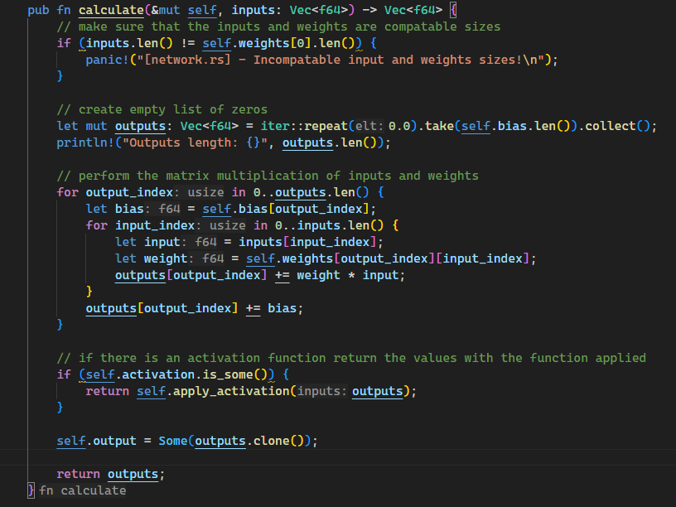Here is the bug free function:

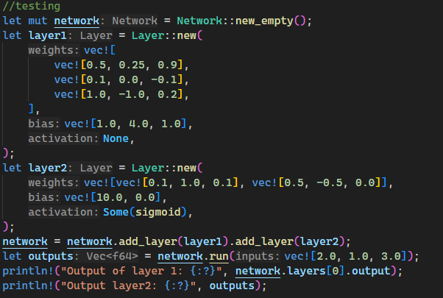Now that the neural network code has passed the test, its safe to apply to the main program. However, first, when I was writing the test code, I found that constructing the layers manually is very time consuming and the code will get very messy very quickly so I’m going to make a better layer constructor which randomly initialises the weights and biases ready for use in the genetic algorithm.

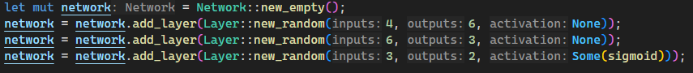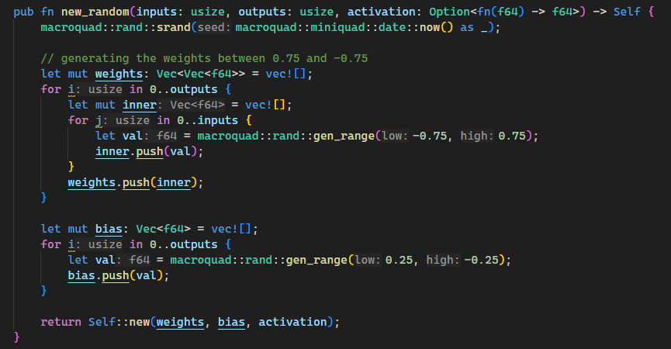Creating a network now – the easier way

Figure - Test code

The random initialisation of the weights and biases

For the time being I’m going to randomly choice values between -0.75 and 0.75 for the weights and values between -0.25 and 0.25 for the biases. These values are quite important and will most likely need tweaking later, but for now I have just chosen these arbitrary values.

Figure - The random initialisation code

*Testing stage 4*

|  |  |  |  |  |  |  |  |
| --- | --- | --- | --- | --- | --- | --- | --- |
| Test Name | Network Structure | Weights | Biases | Input Data | Expected Output | Actual output | Result |
| 4.a | Network with 1 layer with 1 neuron | [1.0] | [0.0] | [3.5] | [3.5] |  | **PASS** |
| 4.b | Network with 2 layers with, of size 2 and 1 | [[1.0, 0.5], [0.9, -0.5]]  [[0.1, 0.2]] | [3.0, -2.5]  [1.0] | [1.0, 2.0] | [0.98] |  | **PASS** |
| 4.c | Network with 1 layer with 1 neuron, with a sigmoid activation function | [0.9827] | [-1.0] | [123.0] | [1] |  | **PASS** |

Development Stage 5

Recap

**Stage Five:** Attaching a controller to a **car** object so it can use its own neural network to move the car, this involves choosing what data inputs enter the network and deciding the ‘bare metal’ anatomy of the network.

First, we need a super object to handle all the cars, I’ll call it the **population** class. The population class needs to:

* Store all the **cars** in a list
* Handle drawing and updating all the **cars**
* Eventually handle the evolution cycle, i.e. carry out the genetic algorithm
* Spawn all the **cars** on the track
* Store the **track** object
* Handle drawing the **track**

**Note**: I’ll be isolating the population code into another file called *population.rs*

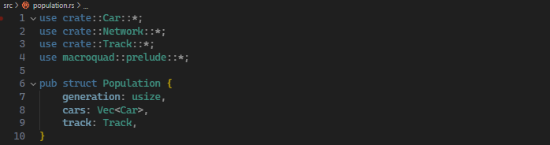

Constructor:

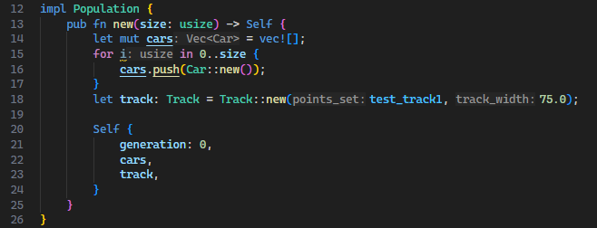

Now the population class needs a **draw** and **update** function to be called every frame from the main function.

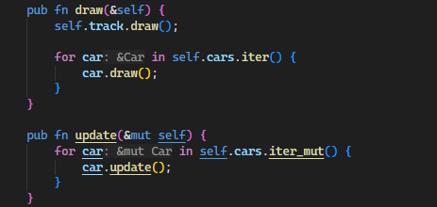

These functions are very self-explanatory and didn’t take much planning.

Now we can create a population in the main function.

Note: Now the car will no longer be controlled by the keyboard, since we will be implementing the AI controller now.

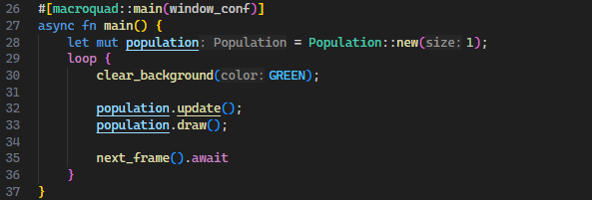Everything runs fine, but now we need to stop spawning the car in the middle of the screen but instead at the start line. So now I added a **start_position** argument to **car** class constructor. And I added a **get_start_pos** method to the track class:

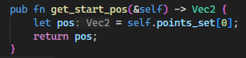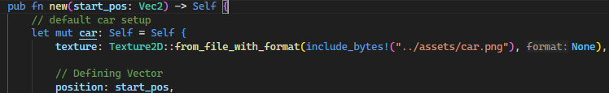

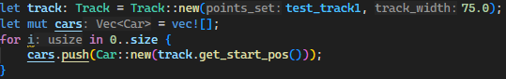

When running the code the car spawned slightly offset from the start point. I quickly realised this is because the position of the car defines the position of the top left of the car sprite, so I just need to offset the start pos by **car_width / 2** and **car_height / 2**. As shown below:

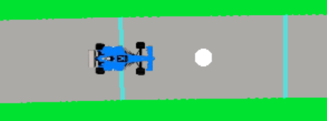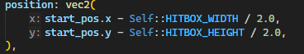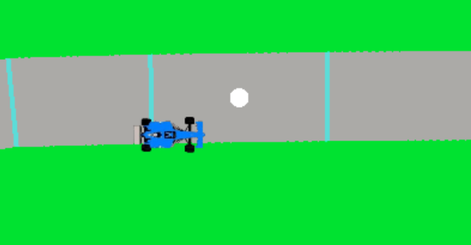

Now when I run the code the screen looks like this ->

Designing the AI controller

What inputs/sensors does the controller need?

* Ray casting sensors to sense the edge of the track, should be cast in a range of directions around the car
* The car’s x velocity
* The car’s y velocity
* The car’s speed
* The car’s angle
* The car’s steer value

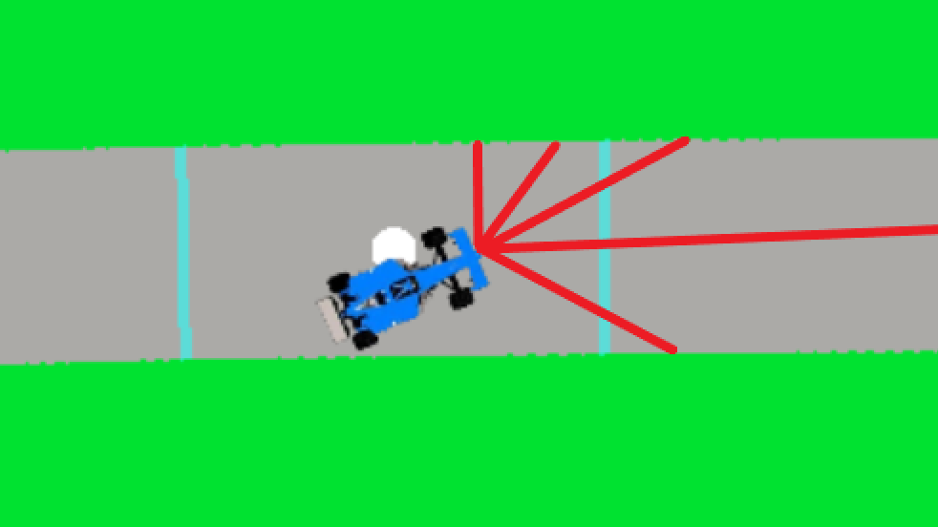

This diagram shows the car casting its sensor rays, and they stop when they hit the barrier.

Note: The diagram shows the rays protruding from the front centre of the car whereas in reality the rays will be cast from the centre of the car’s hitbox

**How to cast the rays:**

* Get the direction vector of the ray, from the car’s angle.
* See which sector line the car will interesect with
* Calculate the distance between the source and the sector line

The maths:

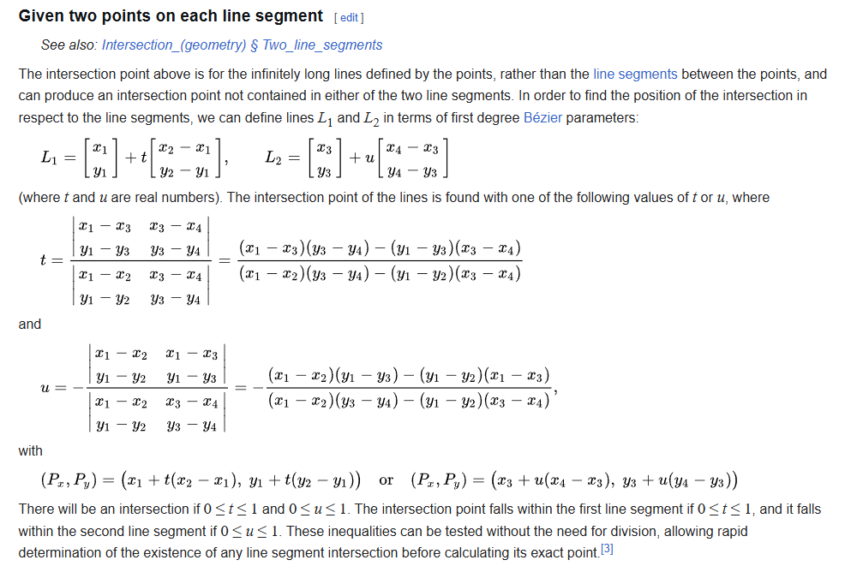

Figure - <https://en.wikipedia.org/wiki/Line%E2%80%93line_intersection>

So all we need to find is the 4 coordinates which define the 2 lines and then apply this series of maths to complete the problem.

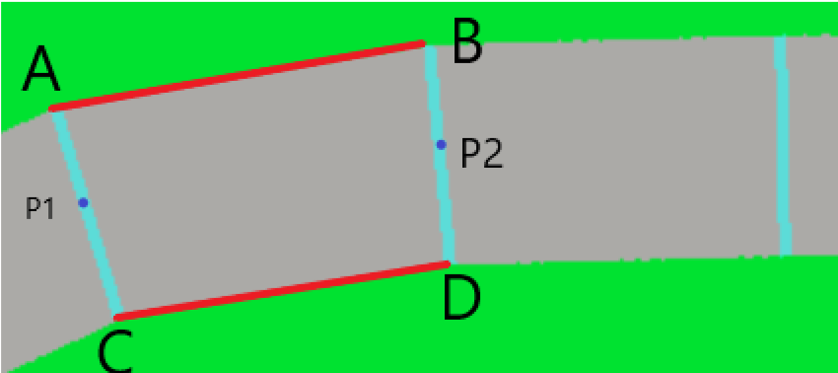

We need to find the points A, B, C, D from the diagram above, given points p1 and p2 which are the sector points.

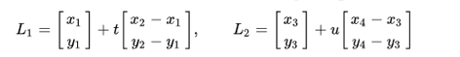

L2 is the sector boundary line and we have the points x3 and x4 so can complete the form. However, for L1 (the ray line) x1, y1 is the center of the car hitbox but instead of doing x2-x1 and y2-y1 we can just find a direction vector from the ray’s angle instead of finding a second point on the ray line.

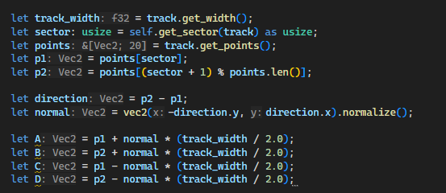

I wrote this code to find points A, B, C and D in the diagram above. Lets draw these points to the screen to test if it works:

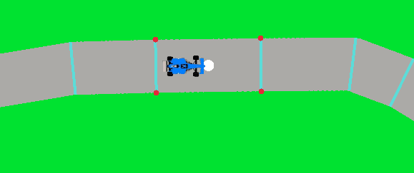

And it works a treat! No onto the maths:

So we need to calculate the values of **u** and **t**. It’s just the the matter of copying down the formula on the right of the two below diagrams into the rust code.

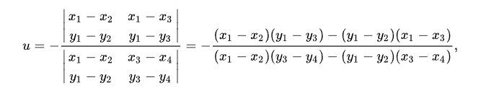

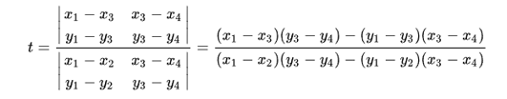



Note: We can only check if 2-line sectors meet at a time. So, the code below will check the intersection between the ray and **A-B** line.

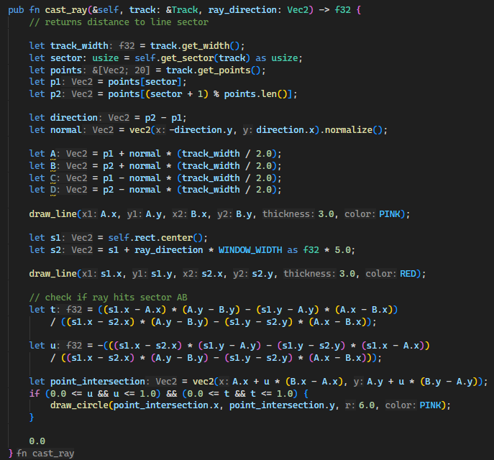

#

For testing, the current code will draw a point at the calculated point of intersection in pink on the screen.

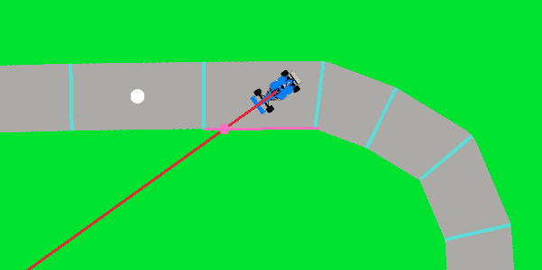

As you can see the intersection code is currently working. However, its only checking intersection with one set of sector lines in the car’s current sector (the one coloured in pink). But we need to check for intersections across the whole track and take the shortest intersection point as the one to return.

Algorithm

What needs to happen:

Starting on the current sector, check if the ray intersects with either of the sector’s boundary lines. (It can only intersect with one of them)

If it does, save that point to intersection point variable and the ray’s distance to the point to the maximum distance variable.

Go through all the other sectors on the track and if they intersect with the line **and** they intersect at a point closer to the car than the previous intersection points then save that new intersection point as the intersection point variable and its distance to the maximum distance variable.

The intersection point will be the point which gives the shortest distance to the car.

*Writing it in the code*

In order to keep the code, clean I wrote a function which handles the line intersection formula in the *utils.rs* file.

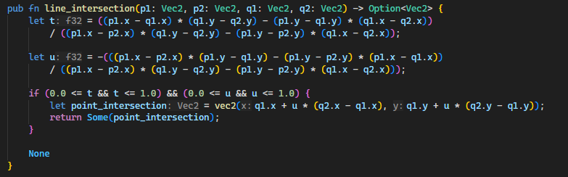

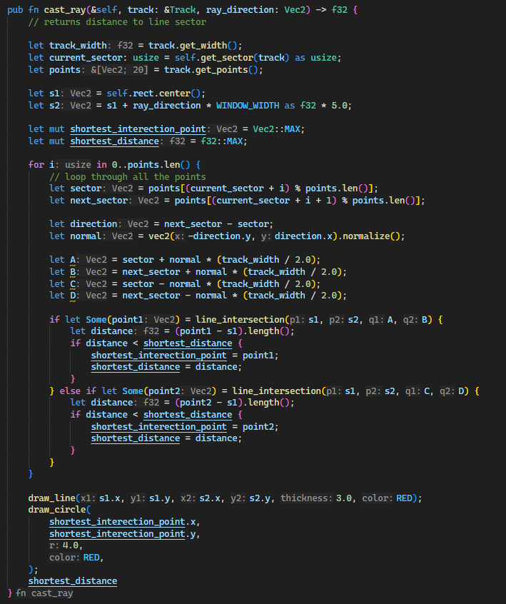Here is the final completed function:

*Testing the code*

After running the code, the line intersection seemed to work correctly. You can find the video of the running code at***Documentation/Video/ray_cast_test.mkv***

However, as is visible in the video, sometimes the ray would not appear at all or it would end early etc. This wouldn’t happen very often during the simulation but over time would probably negatively affect the AI learning process. So, it needs to be fixed.

The problem was obvious when I drew the sector lines onto the track:

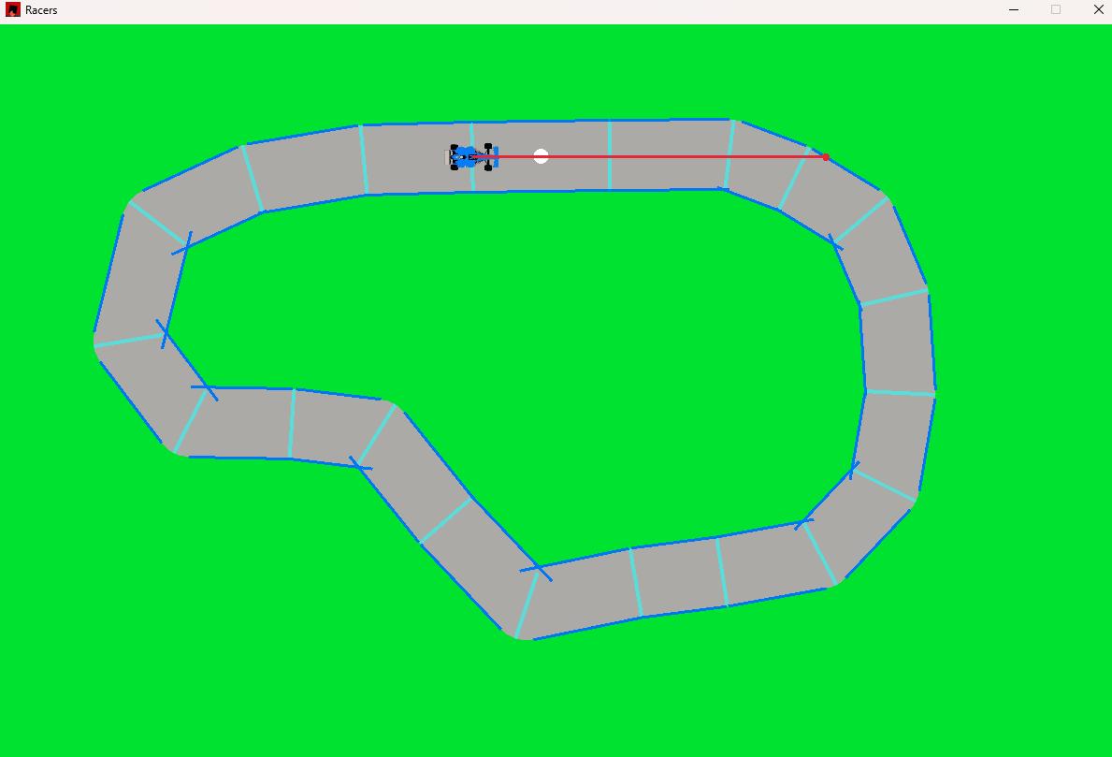

The error occurs because when calculating the sector corners, **A, B, C and D** the normal calculated only takes into account the next sector and not the previous ones or the next, next sector along.

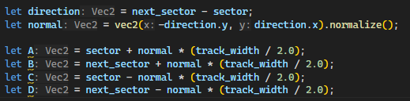

So, when calculating the normal to get the points **A** and **C** (the points on the left) You need to take the average normals of the 2 sector lines between which it lies as shown in the diagram below:

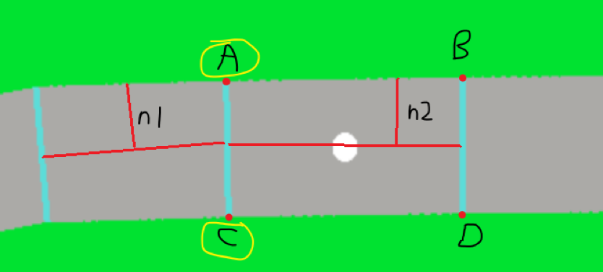

The points **A and C** will need to be found using the average normal vector of **n1** and **n2** and then the points **B and D** will need to be found using **n3 and n2**.

The code for this looks a big disgusting, the variables using the word **left** are used to describe the values needed to calculate **A and C** (the points to the left of the sector) and visa versa for the keyword **right**.

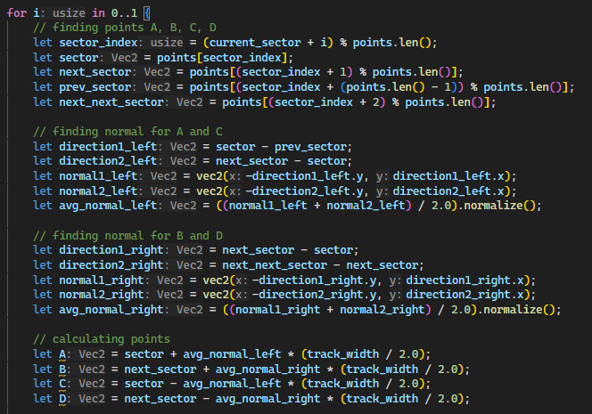

*The Result:*

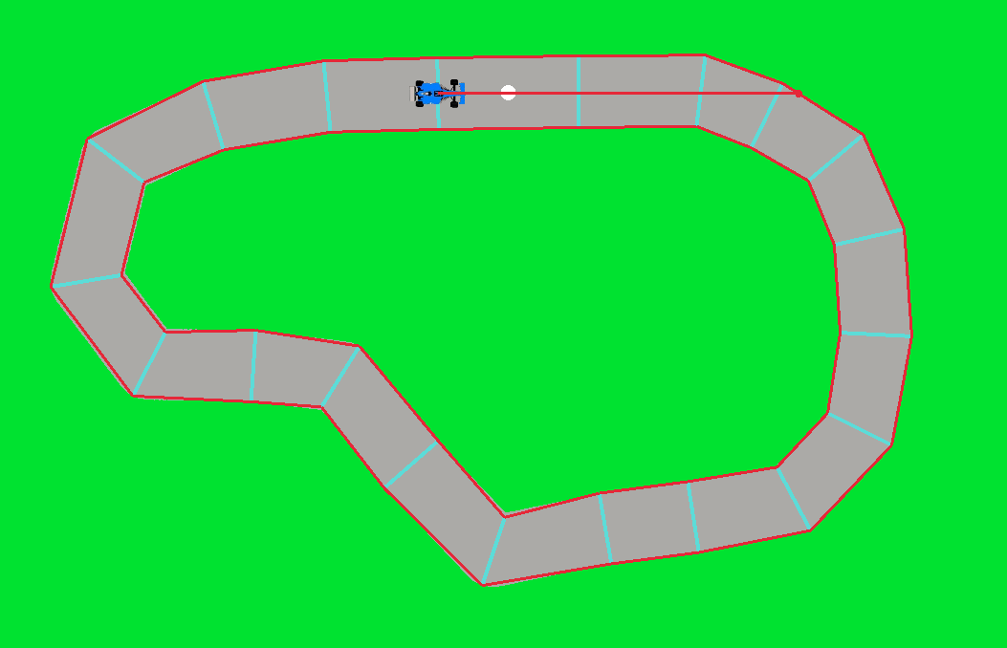

Wow! What a beauty! Now with this fix, the sector lines are defined with much more accuracy. Now the problems discussed above will no longer occur.

***cast_ray whole function:***

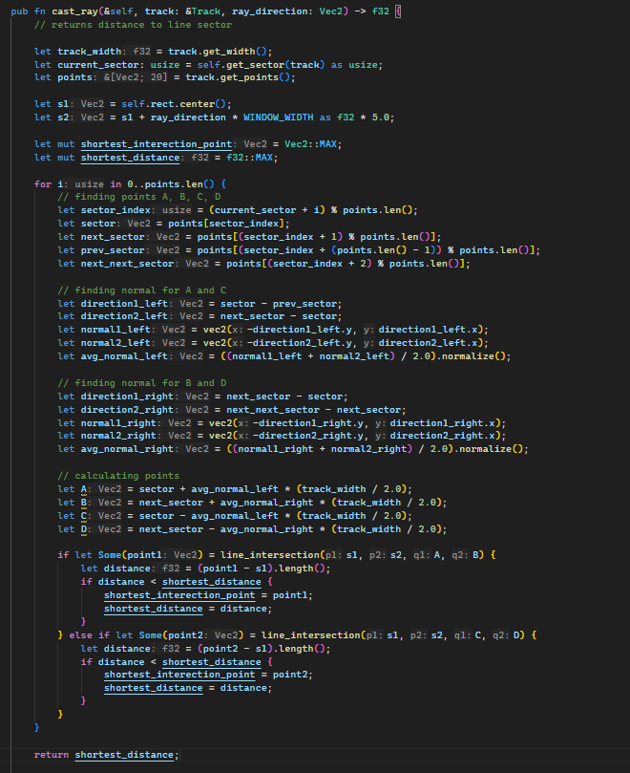

Now let’s cast multiple rays:

Since the ray casting is isolated in its own function, it should be easy to cast multiple of them:

The cast ray’s function arguments:

* Number of rays
* Car’s field of view – FOV
* Reference to track object

The code in pseudo code:

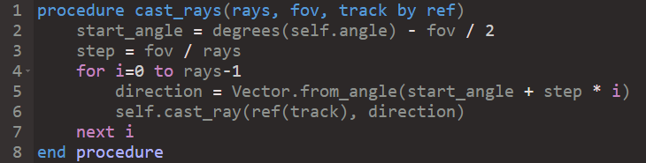

Note: The FOV argument will be measured in degrees, so I need to translate the car’s angle attribute into degrees before doing any calculating.

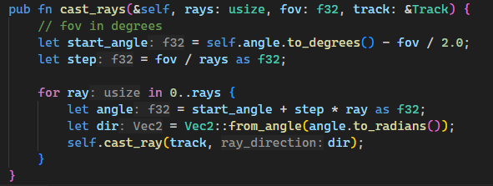

*The code in rust:*

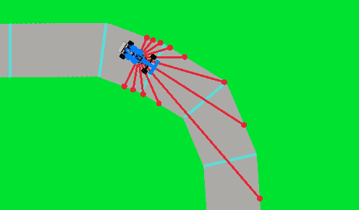*The result:*

Implementing the Car’s Neural Network

accY

accX

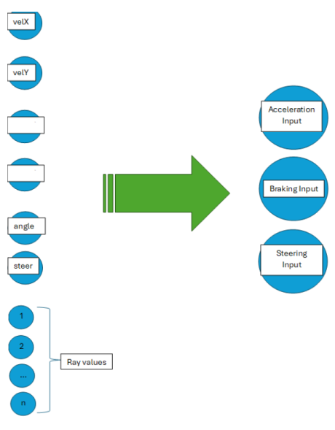

|  |  |
| --- | --- |
| Inputs | Outputs |
| * Ray casting sensors to sense the edge of the track, should be cast in a range of directions around the car * The car’s x velocity * The car’s y velocity * The car’s angle * The car’s steer value * The car’s acceleration x * The car’s acceleration y | * Acceleration_input * Brakes_input * Steering_input |

Building the neural network

Layers:

* Input layer – **6 + (number of rays)** neurons, no activation
* Hidden Layer 1 – **8 neurons**, no activation
* Hidden Layer 2 – **5 neurons**, no activation
* Output Layer – **3 neurons** activation sigmoid

So we need to add a **brain** to the car class

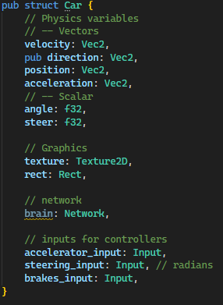

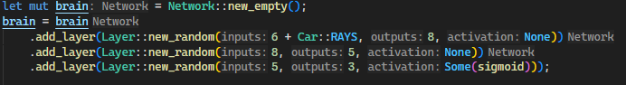*Network Initalization*

So that’s our network created, now I need to generate the network’s input every frame to get the car’s movements.

The inputs need to be normalized between passing them into the neural network, i.e. change them to values between -1 and 1.

I modified the **cast_rays** function to return a vector (list) of the ray distances

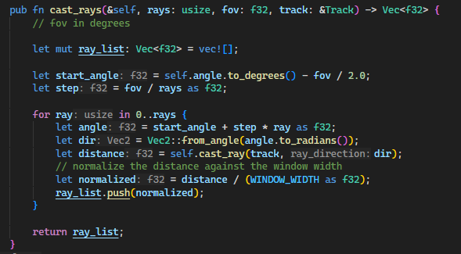

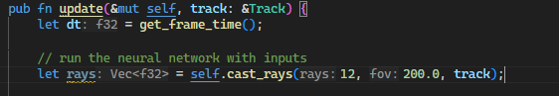

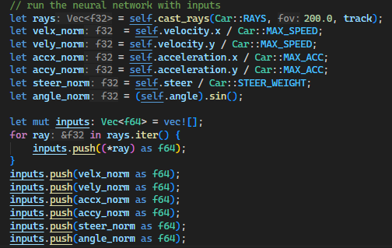Note: that now the update function needs access to the track object, a reference to the track object must be passed to the update function – hence the new function signature.  
Normalising most of the input data is quite easy since the class has constant MAX values for most physical quantities, and the angle will benormalised by passing it as sin(x) rather than the angle x.

Figure 5-Collecting normalized inputs

I printed the inputs array to the console to ensure they were all normalized



If you zoom in enough you can see that they are all between -1.0 and 1.0

Running the network

Now we have the inputs in the correct format, we can pass it into the network and set its outputs to the corresponding car’s input variables.

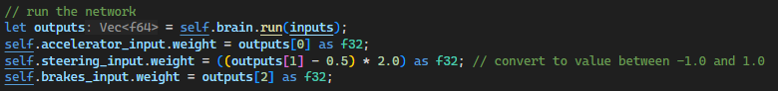

Even though its pretty useless because there’s no population control its quite interesting to watch the current state of the AI.

The video is in ***Documentation/Videos/AI_first_run.mkv***

Development Stage 6

Recap

**Stage Six:** Implementing the genetic algorithm for taking 2 controller’s and mixings their networks (plus a little mutation) to create a new controller.

Refining the population class

*Current Class Diagram*

|  |
| --- |
| Population |
| Attributes:  + generation : int  + cars: Car []  + track: Track |
| Methods:  + draw()  + update() |

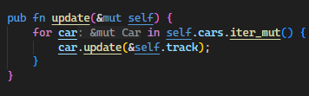*Draw and Update functions*

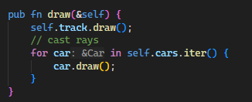

What does the population update function need to do?

* Go through every car and call its individual **update** function
* If a car goes off the track, freeze it as if it crashed
* Calculate the fitness of each car
* Reset the population if the generation timer is up

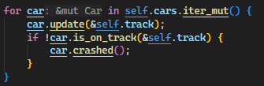

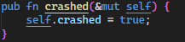This loop in the population update function, will update the cars and then if they are off the track then they call the setter function car.crashed() which sets the car’s crashed boolean value to true:

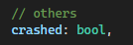

Figure -Adding crashed attribute to the car class

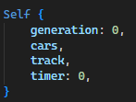I added a timer to the population class as well as a constant **generation time** value



And the image below shows the **new_popluation** function which calls the reset function on every car object.

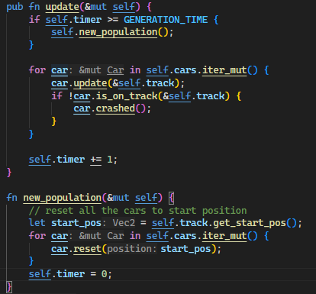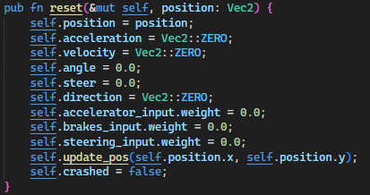

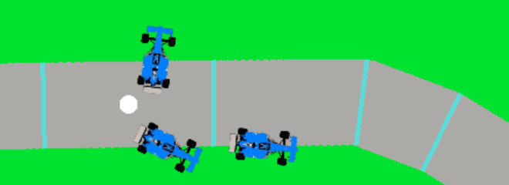

Figure 7- Shows all 3 cars crashed well before the timer went off

**RESULT:** I ran the code and the timer was a little long and the cars would all crash before the timer was up. So I added a conditional statement which also resets the popluation if all the cars have crashed:

First, I have to create a function which determines if all the cars are crashed

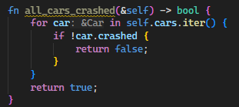 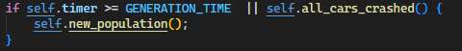

Here is a video of the current state of the project at

*Documentation/Videos/three_car_population.mkv*

As you can see in the video, the three cars’ move the same way and thus crash in the same place every population, this is because they still share the same neural network from the previous generation therefore, they respond the exact same way to their environment

So, now its time to implement the reproduction part of the genetic algorithm.

The genetic algorithm steps

1. Pick the 2 well performing individuals
2. Perform a genetic 1-point-crossover on their weights and biases
3. Add some minor mutation to the weights and biases
4. Repeat until you have a new population of the same size

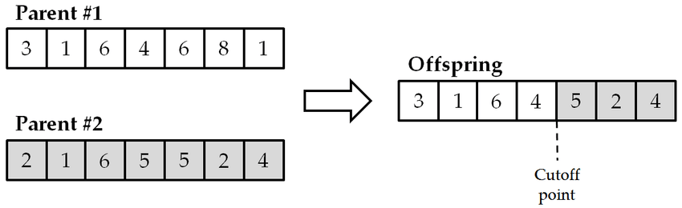

Figure - single point crossover diagram from <https://www.researchgate.net/figure/One-point-crossover-operator-example_fig2_322351489>

Genetic crossover algorithm in psuedo code

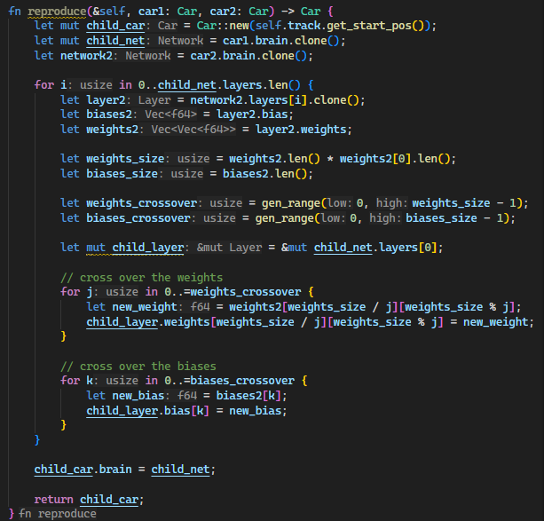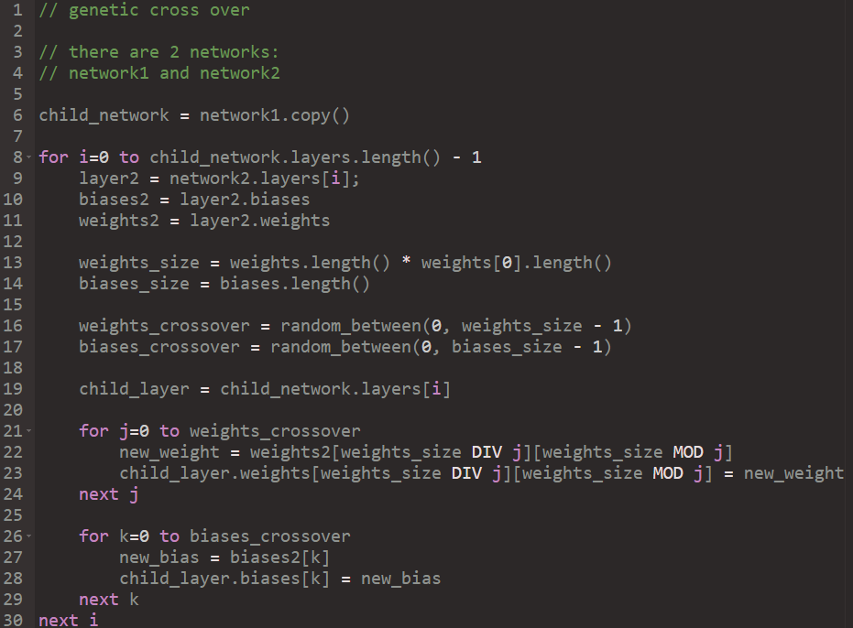

*In rust:*

**Now lets sprinkle in some mutations to the weights and biases randomly**

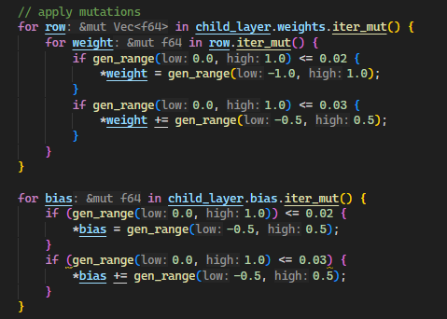

Chance of total mutation: 2%

Change of partial mutation: 3%

These mutation values are temporary for now, but after analyzing the algorithms efficiency these values may be tweaked later!

After writing this code I realise that the previous car’s **reset** function is not necacary since we will be creating new fresh **Car** objects every time we create a new population. So I deleted that!

Simple fitness function:

A fitness function will determine the perfomance of a individual controller so that the best controllers can be chosen for reproduction.

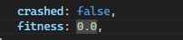Need to add a fitness value to the Car’s object so that it can be continuously calculated. 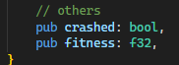

For now lets create a fitness function which only tracks how long the car has been alive for so the algorihtm will promote the longest survivors:

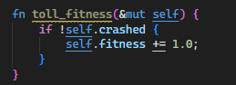 This will be called every frame!

And then a **final** fitness calculation:

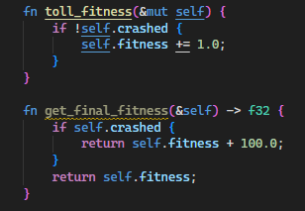

The new **new_population** function: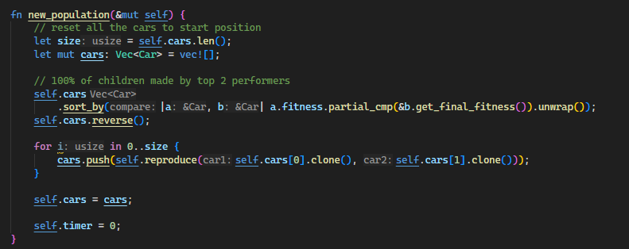

This function takes the 2 best perfomers and creates a new population by reproducing these two individuals **n** times. Note that line **61** is a one line solution way to sort a vector in rust which I found [here](https://rust-lang-nursery.github.io/rust-cookbook/algorithms/sorting.html). But it sorts it in ascending order when we want decending order so I reversed the list afterwards.

When I was running the code I got an division by zero **error**

I traced the code and found a possible division error in the reproduce function here:

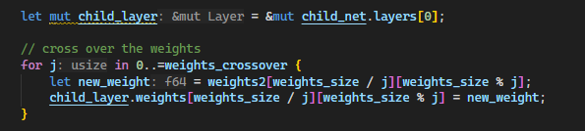

The division should be the other way round, i.e.

* **j / weights_size**
* **j % weights size**

The issue is that the j value can take a zero value whereas the weight_size variable cannot take a zero value.

There is also another issue, the indexing through **errors** because I used the total size of the weights matrix rather than just the size of one row of it:

The size of one row of the weights matrix is given by **weights2[0].len(),** you can use the first index **0** because the matrix should be of uniform size.

Here is the new fixed code:

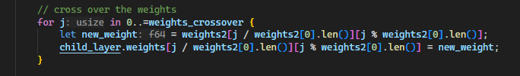

Now the simulation technically works, however its result is rather redundant. The cars will try to survive the longest, this is **not** the goal of the simulation. My point is that the *fitness function defines the behaviour of the simulation.* So now the algorithm’s infrastructure is working, we can alter the **goals** of the simulation by modifying the car’s fitness function.

The video of the simple **survival** simulation working can be found:

*Documentation/Videos/survival_simulation1.mkv*

**RESULT**

As evident in the video, the car’s attempt to maximise their lifespan in a very visible way between generations. However, after a few generations the result is not very good since the population is so small.

Note: The ray tracing intersection points are still being drawn and I removed that now.

I’ll rerun the simulation with a population of 25, and print the max fitness to the console after every generation. But every few generations I’d get this error:

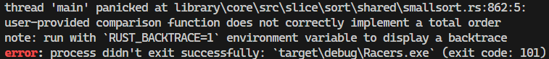

I searched up this error and found this on the github forums:

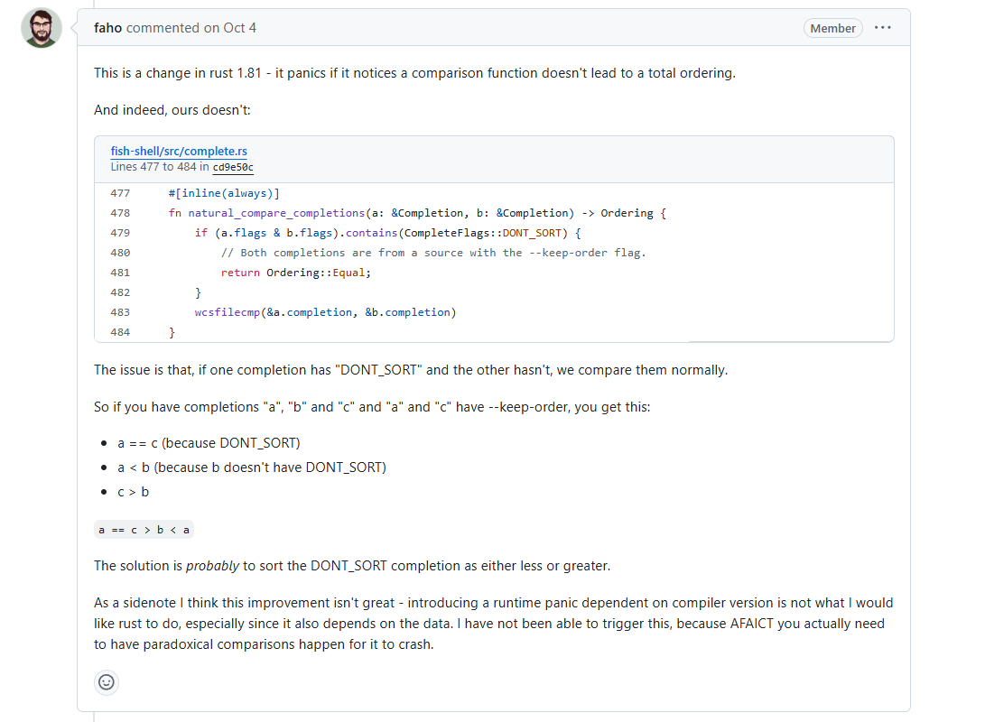

Figure - <https://github.com/fish-shell/fish-shell/issues/10763->

The problem is that in rust the float 32 bit types cannot be ordered (they don’t exhibit the **Ord** trait) so the solution is to store fitness as an integer value instead of a float value, this makes more sense anyway (you can’t have a fraction of a ‘well done’).

Changing the fitness attribute to a Int in the class’s blueprint

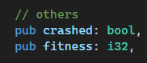

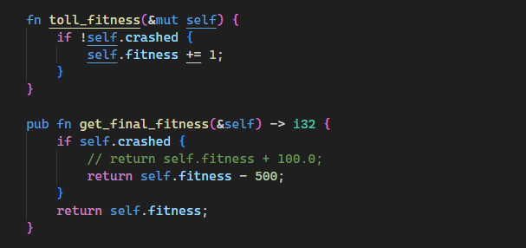**I also need to edit the return types of the fitness functions:**

**Note**: When rewriting these functions, I noticed that before, the **get_final_fitness** function would add 100 fitness if the car had crashed instead of decrementing the fitness. This is shown by the commented-out code and its replacement below.

Now with this fixed, I reran the program and let it run for 5 minutes to see the results.

**RESULT**

However, after watching for a minute or two the cars were not improving at all really, then I printed out the list of cars which were sorted according to their fitness values.

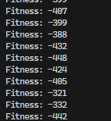It must be a logical error with the **one-line** sorting implementation in the **new_population** function. Simply re-writing the line to this form seemed to correctly sort the list:

Now the list is sorted:

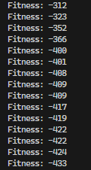

Note: Since its now ordering **b against a** rather than **a against g** like before, there is no need for the reversal of the list after the sort.

**Results of second 5-minute run:**

Here is the state of the simulation after about 5 minutes of run time:

*Documentation/Videos/full_run_1_result.mkv*

End of run report:

After watching the results of the 5-minute run, there are 3 notable behaviours that have appeared:

* The cars appear to be moving very slowly along the race track. At first, I thought that my program might be lacking some fps but then I realised that the cars are actually driving at such low speeds in order to increase their life span and thus their fitness value. This is confirmation of the behaviour-fitness relationship since the population is finding ways to increase their potential fitness value. It’s also a good sign that the genetic algorithm is working as expected and quite efficiently – since only after 5 minutes the car’s had already nailed this technique.
* The cars attempt to make it round the race course rather than just sitting idly at the start. I suspected that after 5-minutes of training the AI would just let their car sit in the middle of the race track and not move, since that’s a guaranteed way to boost fitness. However, most of the 25 cars in the population would attempt to move around the track without stopping – I believe that it is due to the fact that the nature of the neural network promotes non-zero inputs (due to non-zero biases and non-zero weights). I.e. its much harder for a NN to output the value 0.0 (as in **do not accelerate**) than it is to output a value like 0.2 (as in **accelerate a little bit**).
* The cars would make an effort to remain on the race track even when moving at slow speeds. This is because the fitness function punishes crashing (going off track) and encourages surviving, so naturally the AI controllers attempt to keep the cars inside the track limits to maximise their fitness values.

ISSUES

* The population now survives longer than the generation time, thus it will hit a maximum fitness value and not improve from there. Therefore, now I’m going to make the generation time limit very large so the cars will much sooner all crash than reach the time limit. This will promote continuous improvement.

Let’s update the fitness function!

Here’s a table which displays behaviours to encourage and behaviours to discourage

|  |  |
| --- | --- |
| **Encourage** | **Discourage** |
| Staying on the track | Crashing |
| High average speed |  |
| Reaching checkpoints |  |
| Time it takes to reach checkpoints |  |
| Finishing a lap |  |
|  |  |
|  |  |

New additions to car class:

* **timer - int** – to time sector times (incremented every frame, reset when car hits new sector)
* **cumulative_speed** **- float**– to calculate average speed
* **prev_sector - int** – a variable which saves the car’s current sector, so we know when it reaches a new one

Additions **to toll_fitness** function

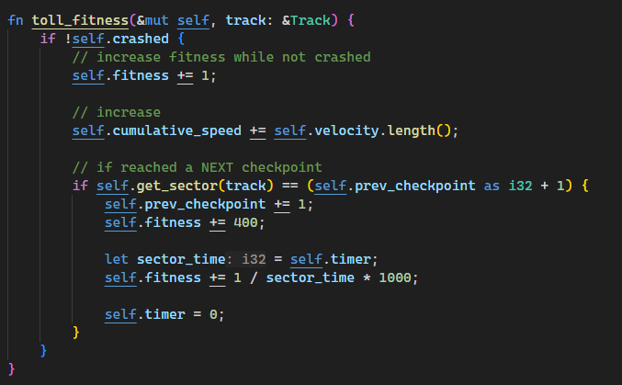

**Note**: the function only rewards extra fitness when a car goes to the **NEXT** sector (so it can’t gain fitness by going backwards). Also, the function adds an inverse of the sector time to the fitness value, so that going quicker through a sector rewards fitness point.

Additions to the **get_final_fitness** function

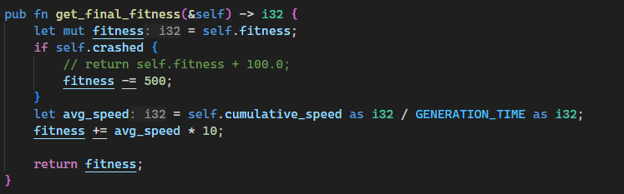

Now this function calculates average speed and awards fitness points accordingly.

The code for encouraging finishing a lap

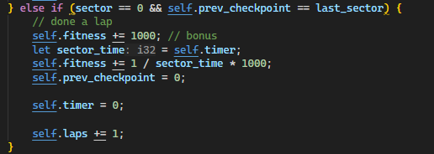

The code awards a bonus for completing a lap, and also this code is required so that if a car completes a lap, its sector times will reset and it can continue gathering fitness from completing sectors.

Note: When the cars are placed at the start line, their current sector is set to the final sector so as soon they move, they will ‘complete a lap’ thus the cars are rewarded for moving off the start line. However, it also means that the car’s lap counter will be **1** if the car moves off the line.

Testing and Fixing

For testing purposes I’m going to export the best fitness data from each generation into a csv file so I can analyse it in excel:

**The rust code:**

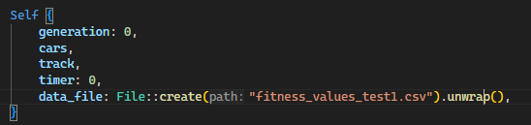

This creates a csv file object which can be accessed inside the code.

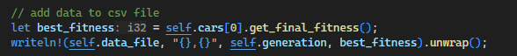

This code writes the data for the current generation to the csv file. I also had to add the code to increment the **self.generation** attribute every time **new_population** has been called.

For each test run I’m going to create a test report which demonstrates the results of the simulation and the potential improvements of the simulation code.

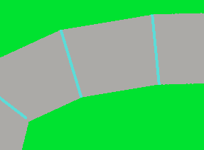Note, For the following tests the track width is no 100px which looks like this

*Test Run 1:*

Car performance graph:

Time lapse footage here:

*Documentation/Videos/TestRun1.mp4*

Analysing Results:

The cars made great progress in the first 20 generations probably due to them discovering all the ways to gain fitness. However, after generation 20 the cars improvement stagnates and also is heavily volatile for the rest of the simulation – without improving very much. The cars managed to finish a lap very quickly into the simulation however they didn’t really learn how to take the corners very quickly or accelerate hard on the straights. Out of the 100 cars, the majority of them crash moments into the generation whereas only a few of them are still racing when the timer runs out. This means that during the cross over and mutation algorithm most of the car’s networks are being altered such that they cannot run effectively anymore. I believe this has something to do with the nature of my cross-over function (which cross overs the weights and biases in every layer rather than just crossing over the **layer** objects), since this would create layers which largely mismatch with each other. Finally, during the middle generations, some cars were exploiting the ‘finish lap’ and ‘finish sector’ rewards by spinning in circle or going backwards round the track. So, I need to discourage going backwards! I also think that the car’s intelligence is limited by the size of its network so perhaps adding another hidden layer would increase learning efficiency.

*Test settings:*

* Generation size: 100
* Car rays: 20
* Generation Time: 1000 ticks
* Data Length: 70 generations

***Test Run 1 improvements***

Discouraging moving backwards through the sectors:

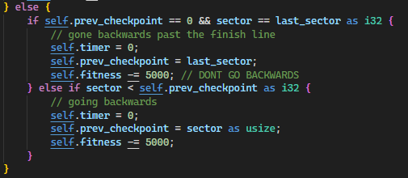

This else clause added has been added to the **toll_fitness** function, it docks fitness by 5000 points if the car is going backwards

Also, for this function to work properly we need to change the car’s starting position to in the centre of the first sector (otherwise the program thinks that the car is in the final sector when the simulation beings):

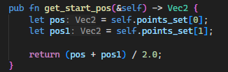

Adding layer to network

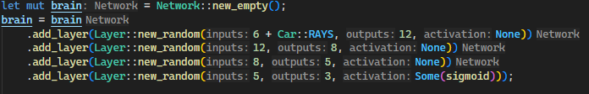

This adds another layer between the input layer and the first hidden layer! It should add a layer of potential complexity to the car’s learning ability.

Tweaking Fitness Values

1. I increased the fitness bonus for **sector time** which should encourage the cars to run quicker
2. I increased the fitness decrease when the car has crashed to discourage crashing
3. Increased the bonus for high **average speeds**

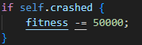

*Test Run 2:*

Car performance graph:

Time lapse footage here:

*Documentation/Videos/TestRun2.mp4*

**Note: I also made cars that have crashed be drawn using a slightly transparent hue so that they don’t clutter the screen as much.**

Analysing Results:

These results were quite promising however there were some clear issues. Again, out of the 150 cars a lot of them would crash at the start (again I think it’s a natural problem with the crossover step during network reproduction). However, the fitness function seemed more promising – at first it would encourage making it to the checkpoints and not crashing (for the top performers) and quite quickly the cars could complete a lap. Once, they had completed a lap they look to improve their sector times so that they can earn more fitness points and make it further along the track.

The shape of the graph is far smoother than test run 1, however you could argue that the top controllers from test run 1 were faster than those from this test run. But the common feature in both the test runs is that after a quick initial learning phase the cars fitness values oscillate (i.e. a generation makes some progress and then the next generation loses that progress). This is a relatively natural occurrence in a genetic algorithm approach (see this one <https://i.stack.imgur.com/jnGvT.png>). However, there are some improvements to be made.

*Test settings:*

* Generation size: 150
* Car rays: 20
* Generation Time: 1500 ticks
* Data Length: 50 generations

*Conclusion:*

The results from these two tests are not perfect, however they facilitate the improvement of the generation over time. In other words, the algorithm **works!**

There are certainly some steps towards improvement that can be taken, i.e. various tweaks and tests to the **cross over** algorithm and more tweaking of the fitness function. However, down the line there is*Development Stage 10* which will tackle all this improvement along with further testing of the genetic algorithm.

Therefore, we have completed the requirements for this stage of development and can move on.

Current Analysis

But before we move on, lets list some of the current issues which will offer context for when we eventually reach **Stage 10**:

* Many cars will crash at the start no matter what, due to the cross-over function.
* After, a while the population seems to reach a plateau where it continues learning in cycles but never shows much forward progress
* Some cars seem to reap rewards by continuously spinning around a checkpoint, thus grabbing the rewards – for that checkpoint – repeatedly in quick succession. This should be discouraged.

Stage 6 Final Testing

**NOTE**: The previous tests in this development stage are more conclusive of the progress made during this stage, however these following tests will check off the requirements set out in the development plan.

Development Stage 7

Recap

1. **Stage Seven:** Adjust population object to keep track of various sector times, lap times and display them to the user. It should also track the best performing car at all times.

Before starting stage seven, I think it’s good practice to revise the class diagrams for each of our program’s objects in order to avoid confusion.

…

Lateral Friction?

Before starting the stage there is also a small problem with the car’s physics I want to fix:

*The problem:*

In its current state, the car’s physics produce a rather severe problem. The cars can slide around the track as if their wheels were just one large ice cube. The solution to this (as I found on <https://gamedev.stackexchange.com/questions/26845/i-am-looking-to-create-realistic-car-movement-using-vectors>) is to implement lateral friction to the car’s velocity ever frame. This can be done quite simply using some vector maths.

**We need to:**

1. Calculate the component of the velocity vector which is acting perpendicular (lateral) to the car’s direction.
2. Calculate lateral friction as a fixed scalar multiplied by this component
3. Take away the lateral friction calculated above from the car’s velocity every frame

Algorithm Design in Pseudo Code

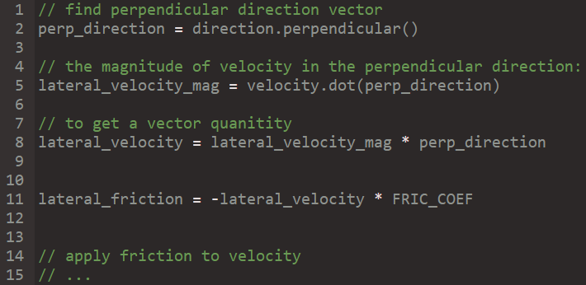

*The code in rust*

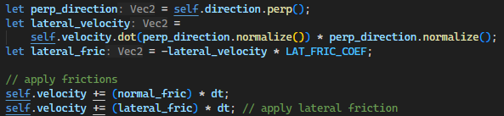

The dot produce of the car’s velocity and the perpendicular direction (normalized) gives us the magnitude of the velocity acting in the perpendicular direction. Then we need to multiply it with the perpendicular direction vector to get back a **vector** value which denotes the component of the velocity in the car’s perpendicular direction, or its **lateral velocity**.

Then we multiply this vector by a frictional coefficient defined here:

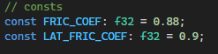

*And finally negate this value and add it to the current velocity (in order works, take it away from the current velocity).*

*The Result:*

I ran the simulation with a small population size to properly see the effect.

Find the video in ***Documentation/Videos/lateral_friction.mkv***

The cars now move in a much more realistic fashion than before – compare this movement to the movement shown in the **TestRun1** and **TestRun2** footage.

Designing

*Tracking lap and sector times*

The population object, in its current state, simply spawns the population of cars and calls their corresponding draw and update functions each frame. However, ideally the class would do more heavy lifting, i.e. track and maintain top times for each generation and also the best times across all generations. This will give the user more useful output data than the excel graphs which were plotted in the previous stage.

So, I would like to create a new class (object) which will maintain and store the timing data of the cars.

The timer object – population object connection

Population Object

Then, when the population object calls on the timer object it will collect back the data and display it to the user through the **UI**.

The population object will feed the timer object with the necessary data each frame, i.e. if a car completes a new lap or a new sector then it will send this to the timer object to keep track of.

|  |  |  |
| --- | --- | --- |
| Top 10 Lap Times | | |
| **Car number** | **Generation** | **Time / seconds** |
| 112 | 40 | 17.01 |
| … | … | … |
|  |  |  |
|  |  |  |
|  |  |  |

Timer object

For now, the timer object should have one data attribute which is a list of the top ten best lap times. I will use the data structure of an **array** because it is easy to manipulate the entries and ensures a set size (10).